**3.1 Quadratic Functions in Vertex Form – Part 1**

A quadratic function is a polynomial of the ______________ degree. The graph of a quadratic function is called a ______________.

Graphs of Quadratic Functions in Vertex Form:

**Part I**: _____________________ Vertex ( , )

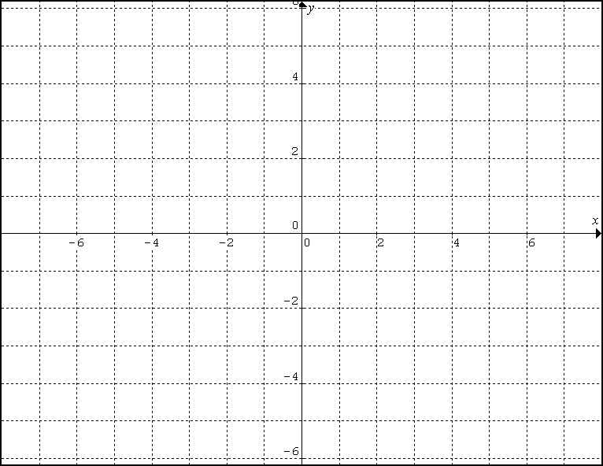

Graph  and using a table of values.

|  |  |  |
| --- | --- | --- |
|  |  |  |
| Coordinates of the Vertex |  |  |
| Direction of Opening |  |  |
| Equation of the Axis of  Symmetry |  |  |
| Minimum/Maximum Value |  |  |
| Range |  |  |

Graph the following Quadratic Functions. These graphs will have a _________________________

a) 

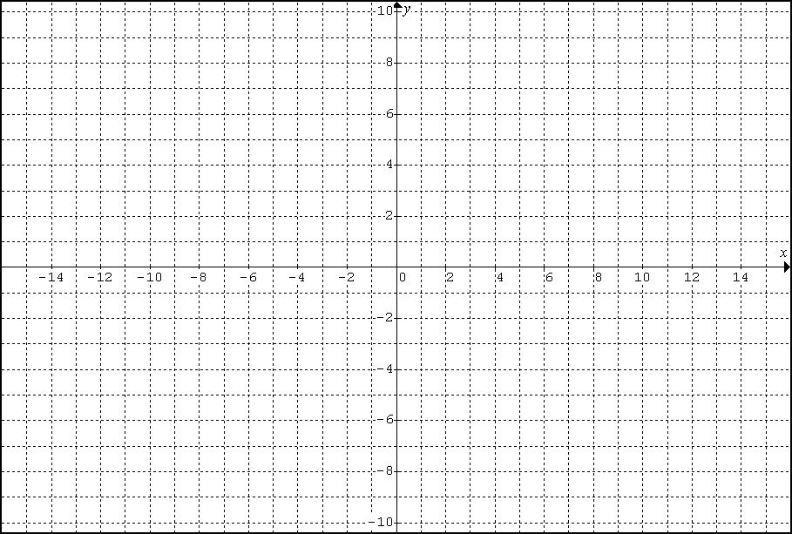

b) 

c) 

d) 

**Part II**: _____________________ Vertex ( , ) These graphs will have a ______________________



|  |  |
| --- | --- |
| Coordinates of the vertex |  |
| Axis of symmetry |  |
| Opening |  |
| Min/Max |  |
| Range |  |



|  |  |
| --- | --- |
| Coordinates of the vertex |  |
| Axis of symmetry |  |
| Opening |  |
| Min/Max |  |
| Range |  |

**Part III**: _____________________ Vertex ( , ) These graphs will have a ______________________



|  |  |
| --- | --- |
| Coordinates of the vertex |  |
| Axis of symmetry |  |
| Opening |  |
| Min/Max |  |
| Range |  |



|  |  |
| --- | --- |
| Coordinates of the vertex |  |
| Axis of symmetry |  |
| Opening |  |
| Min/Max |  |
| Range |  |

**Practice**: page: 157 # 1, 2. You will need to do all graphing questions on GRAPH paper.

**3.1 Quadratic Functions in Vertex Form – Part 2** 

1. Graph the following quadratic functions:

|  |  |  |  |
| --- | --- | --- | --- |
|  | |  | |
| Coordinates of the vertex |  | Coordinates of the vertex |  |
| Axis of symmetry |  | Axis of symmetry |  |
| Opening |  | Opening |  |
| Range |  | Range |  |
| Domain |  | Domain |  |
| # of x-intercepts |  | # of x-intercepts |  |



|  |  |  |  |
| --- | --- | --- | --- |
|  | |  | |
| Coordinates of the vertex |  | Coordinates of the vertex |  |
| Axis of symmetry |  | Axis of symmetry |  |
| Opening |  | Opening |  |
| Range |  | Range |  |
| Domain |  | Domain |  |
| # of x-intercepts |  | # of x-intercepts |  |

2. Without graphing precisely (just a sketch), determine the number of **x-intercepts**:

a)  b)  c) 

3. Determine the **equation** of a Quadratic Function in Vertex Form from its graph.

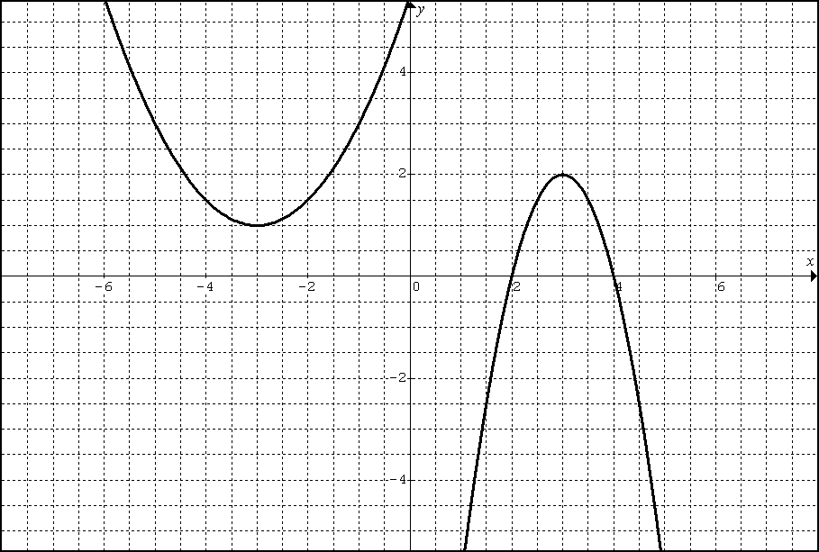 a) 

5. Determine a quadratic function in vertex form that has the following characteristics:

vertex at (0,-3) and passes through the point (5,-4).

**Practice**: p. 157 #4, 5ac, 6, 7, 8, 9 (**QUIZ** next class!)

**3.1 Quadratic Functions in Vertex Form – Part 3** 

1. Graph the following quadratic functions:

|  |  |  |  |
| --- | --- | --- | --- |
|  | |  | |
| Coordinates of the vertex |  | Coordinates of the vertex |  |
| Axis of symmetry |  | Axis of symmetry |  |
| Opening |  | Opening |  |
| Range |  | Range |  |
| Domain |  | Domain |  |
| Min/Max value |  | Min/Max value |  |



|  |  |  |  |
| --- | --- | --- | --- |
|  | |  | |
| Coordinates of the vertex |  | Coordinates of the vertex |  |
| Axis of symmetry |  | Axis of symmetry |  |
| Opening |  | Opening |  |
| Range |  | Range |  |
| Domain |  | Domain |  |
| Min/Max value |  | Min/Max value |  |

The deck of the Lions’ Gate Bridge in Vancouver is suspended from two main cables attached

to the tops of two supporting towers. Between the towers, the main cables take the shape of

a parabola as they support the weight of the deck.

The towers are 111 m tall relative to the water's surface and are 472 m apart. The lowest point

of the cables is approximately 67 m above the water's surface.

a) Model the shape of the cables with a quadratic function in vertex form (write the equation).

b) Determine the height above the surface of the water of a point on the cables that is 90 m horizontally from one of the towers (to the nearest tenth).

**Practice**: page 159 #13, 14, 16, 17, 21

**3.2 Quadratic Functions in Standard Form** 

Starting in vertex form, expand the bracket and look for connections.

$$y=a(x-p)^{2}+q$$

$$y=a(x^{2}-2px+p^{2})+q$$

$$y=ax^{2}-2apx+ap^{2}+q$$

$$y=ax^{2}+(-2ap)x+(ap^{2}+q)$$

$$y=ax^{2}+ b x + c$$

Practice: 1. a)  b) 

|  |  |  |  |
| --- | --- | --- | --- |
| Coordinates of the vertex |  | Coordinates of the vertex |  |
| Axis of symmetry |  | Axis of symmetry |  |
| Opening |  | Opening |  |
| Min/Max |  | Min/Max |  |
| Range |  | Range |  |
| Domain |  | Domain |  |
| y-intercept |  | y-intercept |  |



2. A **rancher** has **100 m** of fencing available to build a rectangular corral.

a) Write a quadratic function (2 variables) in standard form to represent the area of the corral.

b) What are the coordinates of the vertex? What does the vertex represent?

c) Sketch the graph.

d) Determine the domain and the range in terms of the problem.

3. Write the following quadratic function in **Standard Form** ():

a)  b) 

**Practice**: p. 174 # 1, 2 a, 3, 6, 7, 10

**3.3 Completing the Square – Part 1**

From grade 10, we can expand a squared binomial to find a pattern for factoring perfect

square trinomials.

A technic called "Completing the Square" is used to change equations from standard form

into ______________ form. Vertex form is preferred because it is much easy to graph than

standard form.

**Example 1**: Rewrite the following quadratic functions in vertex form.

a) 

b) $y=x^{2}-4x-3$

**Example 2**: Rewrite the following quadratic functions in vertex form.

a) 

b) 

**Practice**: p.192 # 2ac,3ac,4c,6c

**3.3 Completing the Square – Part 2**

**Example 1**: Determine the maximum or minimum value of the function and the value of ***x*** at which it occurs:

a)  b) 

**Example 2:** Verify in two different ways that the two algebraic forms represent the same

function:

 and 

**Example 3:** A theatre company has 300 season ticket subscribers. The directors have decided

to increase the price of a season ticket from the current price of $400. A survey of the subscribers has determined that for every $20 increase in price, 10 subscribers would not renew their season tickets.

a) What price would maximize the revenue from season tickets?

**Practice**: p. 192 # 6bd, 7bc, 8c, 15a, 18ab, 19ab