Ch2 Trigonometry

Prior Knowledge
HYP note: the hyp. must be the "letter by itself"
regardless of the letters used in the question
1) Pythagorean Theorem $a^{2}+b^{2}=c^{2}$

2) Labeling a triangle
ALWAYS label the side opposite or across
from the right angle first, LABEL FIRST!

hypotenuse
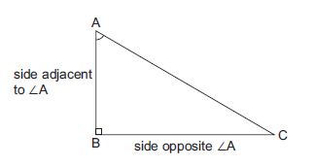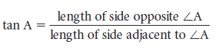

2.1 The Tangent Ratio – a ratio is another word for a fraction. So, the Tangent Ratio is a comparison of two sides of a right triangle.

Ex1.
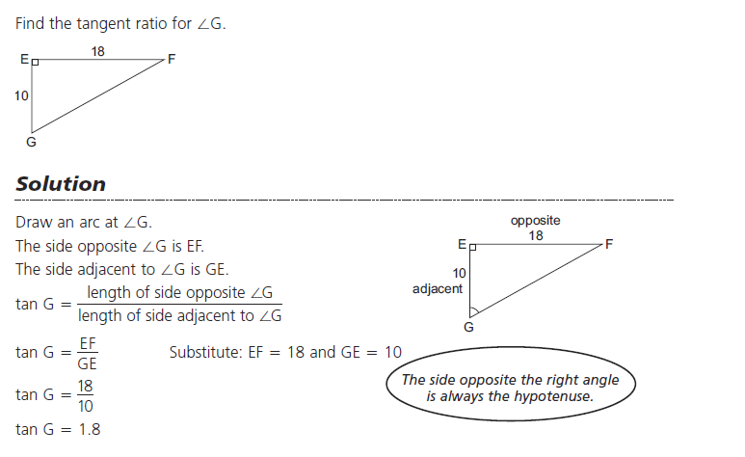
Ex2. To find the measure of this acute angle we need to know 2 sides of the triangle.
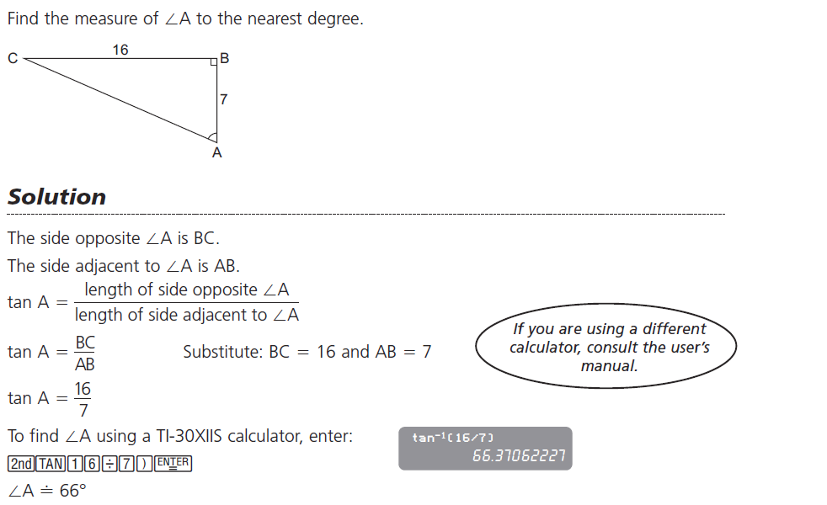
Ex3. – Using the Tangent Ratio to solve a problem for an angle.
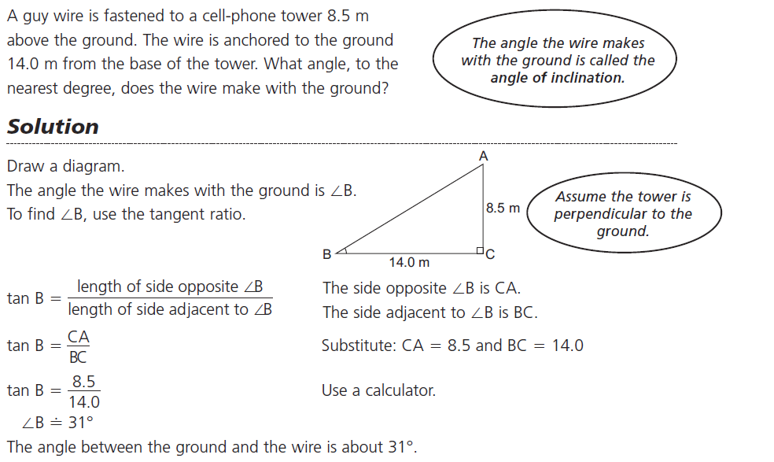
Do Qn's p.88 #1-3
2.2 Using the Tangent Ratio to find Lengths – Any Trig Ratio includes an angle and 2 sides. So, to solve for a side we need the other 2 things. Which is an acute angle and a side.

Ex1.
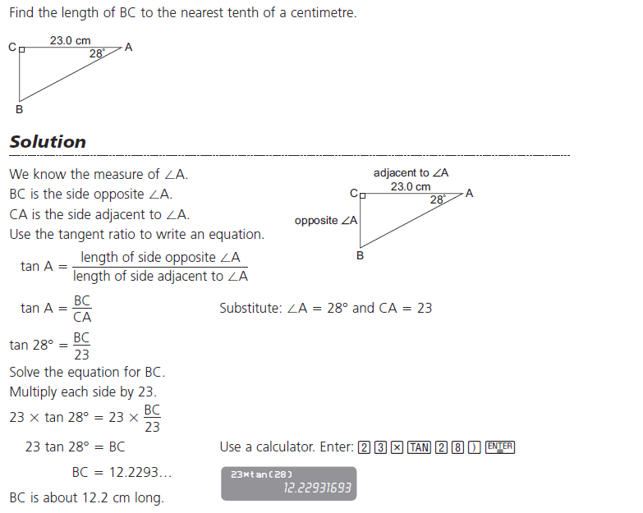

Ex2. – A slightly more difficult Qn is when you are solving for the side which is in the denominator, with the Tangent Ratio this means you're finding the Adjacent side.
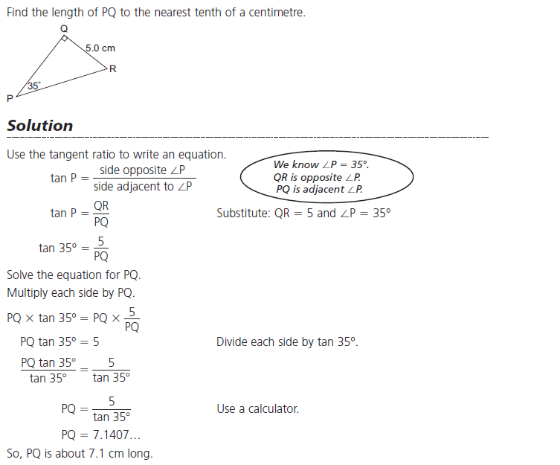

Do Qn's p.88 #4&5
2.3 Measuring an inaccessible height – if by chance you see a Qn on the Provincial exam, it would have to do which how to read a "Clinometer"
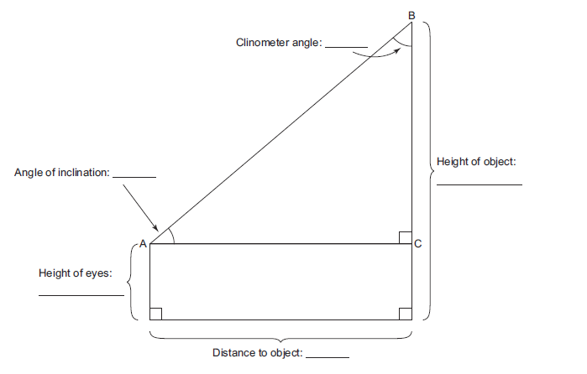
Ex.
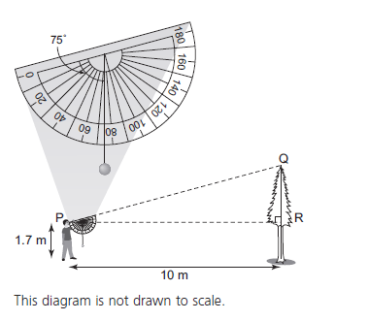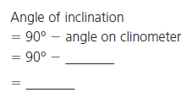

2.4 The Sine and Cosine Ratios – will be used to find both Angles and sides of a Right Triangle.

Prior Knowledge
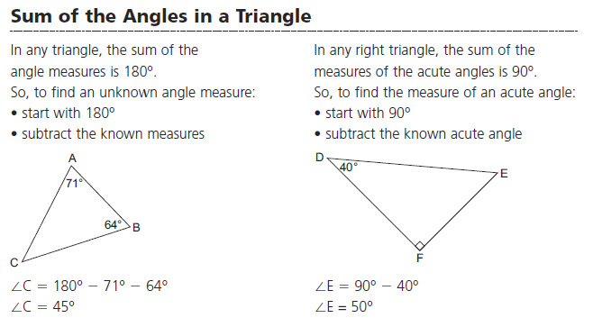
From Your Formula Sheet
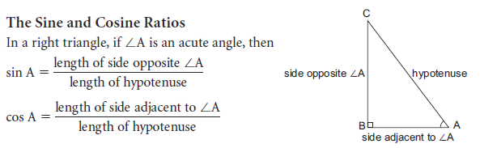

Ex1. Leave your answer as a fraction or decimal, not asking for the angle measurement.
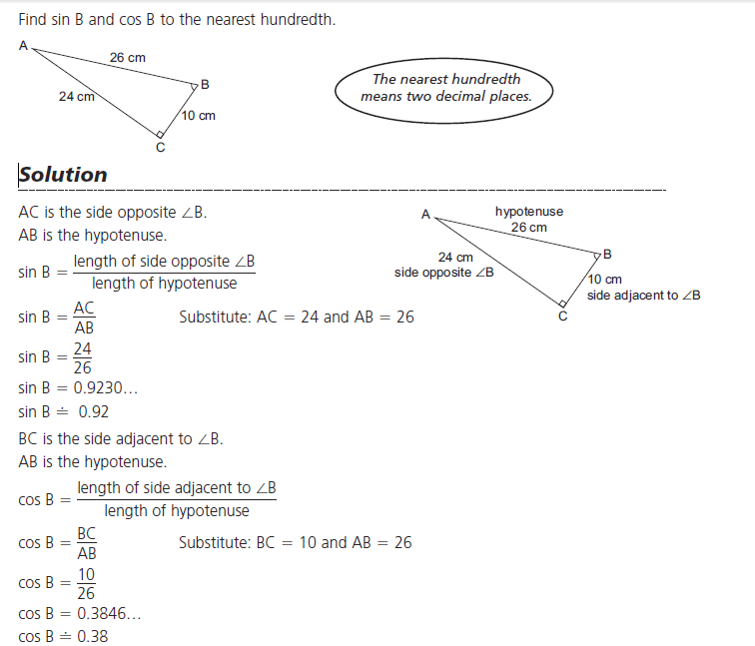

Ex2. Find the Measure of the Angle.
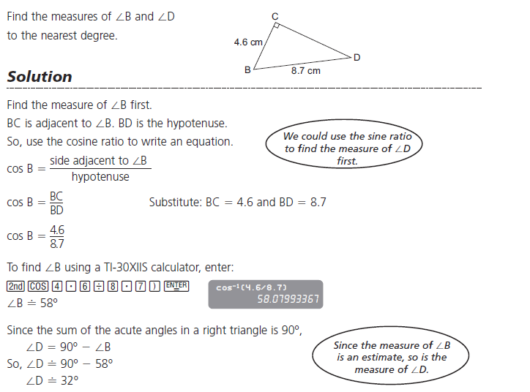

Do Qn's p.104 #1-3

2.5 Using Sine and Cosine to find Side Lengths

Ex1.
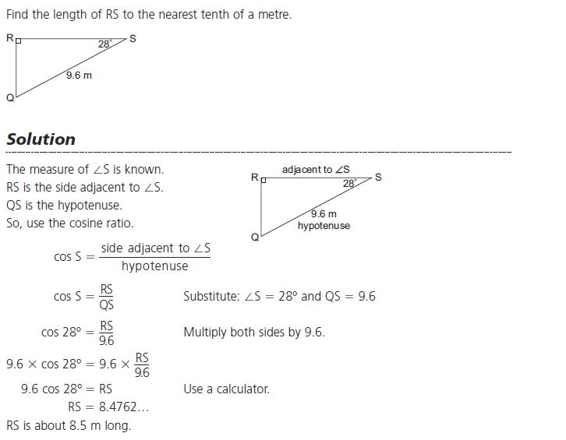

Ex2.
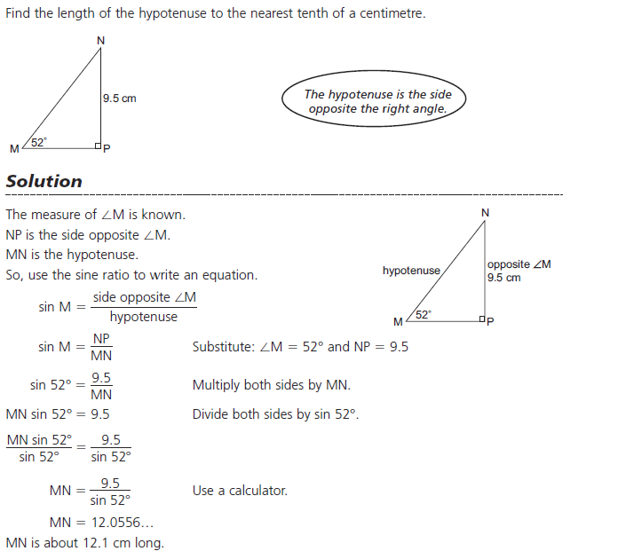

Do Qn p.104 #4&5
2.6 Applying the Trig. Ratios – now we are using all the trig. Ratios (sine, cosine, and tangent) and solving a Right Triangle which means finding all sides and acute angles.
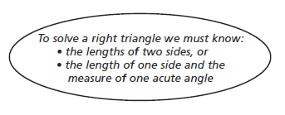
Ex1.
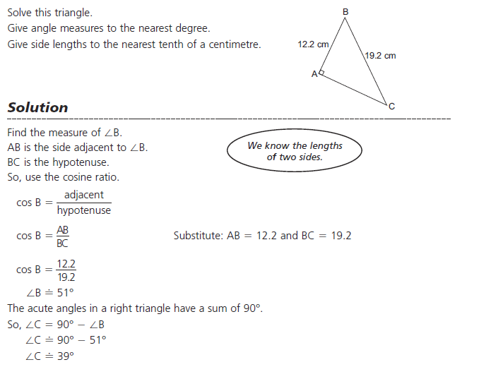
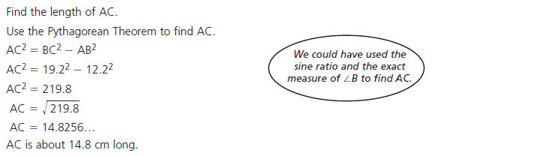

Do Qn p.111 #3
2.6 Solving Problems Involving one or more Right Angle Triangles – Solving Qn's like these usually involve exploiting the fact that the two triangle have a common or shared side.

Ex1.
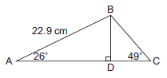
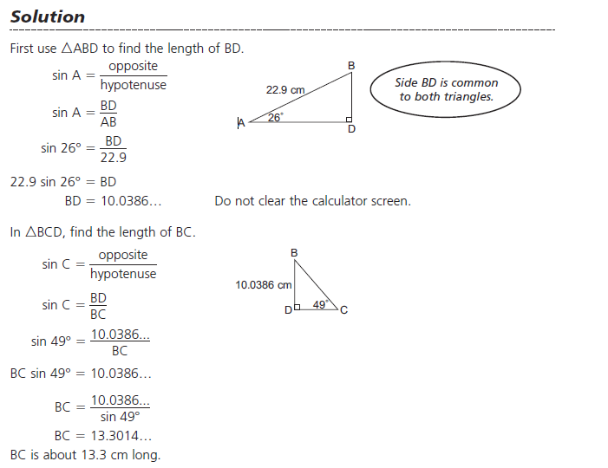

Ex2. Solving Problems involving an Angle of Elevation

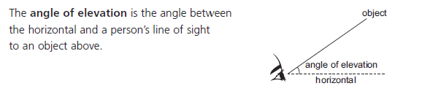
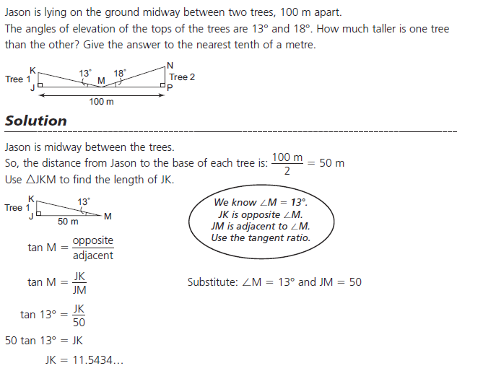

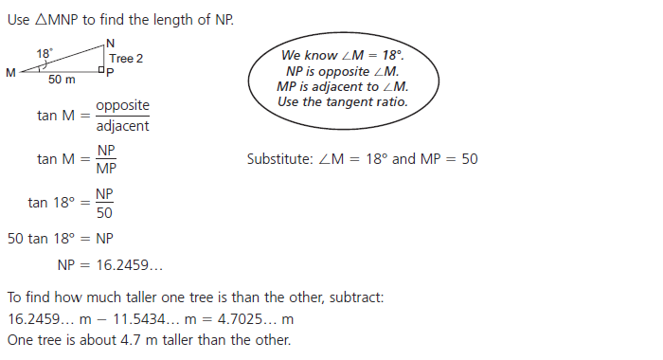

Do Qn p.118 #3
Chp 2 Study Guide

