Chp3 Polynomials

  - Factors and Multiples of Whole Numbers – Using Prime factorization and factor trees we split Whole Numbers into products of their prime factors. Then we used this process to find GCF and LCM of 2 or more Whole Numbers.

Ex.1
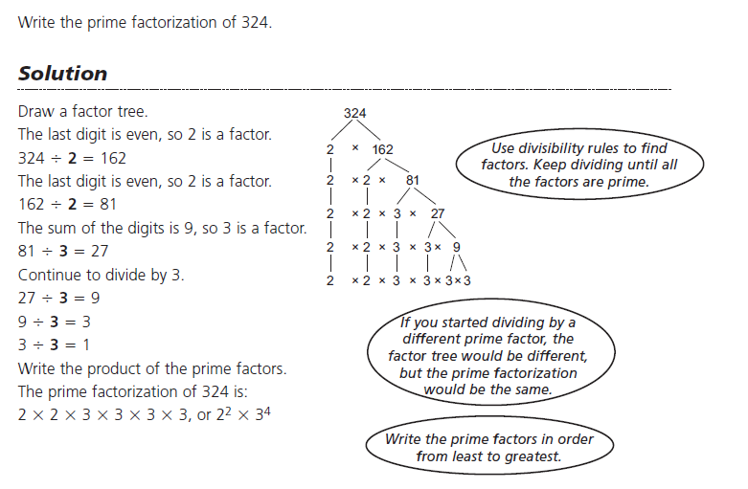

Preferred form for GCF Preferred form for LCM

Ex.2 GCF – the GCF of two or numbers is the largest number which divides evenly into the original numbers, or is listing all the factors it is the largest number which both have in common as a factor.

126 = $2·3·3·7$
144 = $2·2·2·2·3·3$

Using Prime Factorization the GCF is the product of the prime numbers which are in common in each group. So, one 2 and two 3's

GCF = $2·3∙3=18$
Ex.3 GCF

152 = $2·2·2·19$
108 = $2·2·3·3·3$

Using Prime Factorization to list the prime factors, the GCF is the product of the prime numbers which are in common in each group. So, two – 2's

GCF = $2·2=4$

Ex.4 – LCM – The LCM of two or numbers is the smallest number which the original numbers divide into evenly.

Using Prime Factorization to list the prime factors but using exponent notation, the LCM is the product of the all the prime numbers listed whether in common or not, but also the largest exponent of these.

12 = $2·2·3=2^{2}·3$
14 = $2·7$

LCM = $2^{2}·3·7$

Ex.5 LCM

20 = $2·2·5=2^{2}·5$

12 = $2·2·3·3=2^{2}·3^{2}$

12 = $2·19$

LCM = $2^{2}·3^{2}·5·19=3420$

Do Qn's p.149 #1-3(odd letters)
3.2 Perfect Squares, Cubes, and their Roots – In this section we find the square and cube roots of large numbers without the use of a calculator and using prime factorization.

Ex.1 Find the square root without a calculator
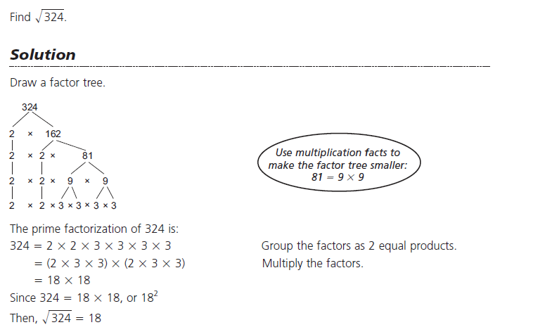
Ex.2 Find the cube root without a calculator
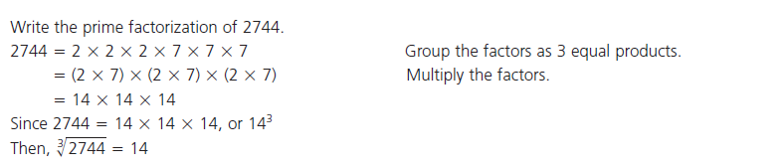

Do Qn's p.149 #6-8(odd letters), 10
3.3 Common Factors of Polynomials – Finding a GCF of a polynomial means writing the polynomial in multiplication form, with the GCF out front and the "left over" terms of the division in a bracket. Answers, in general, can be checked by multiplying the GCF back through the bracket to get the original polynomial.

Ex.1
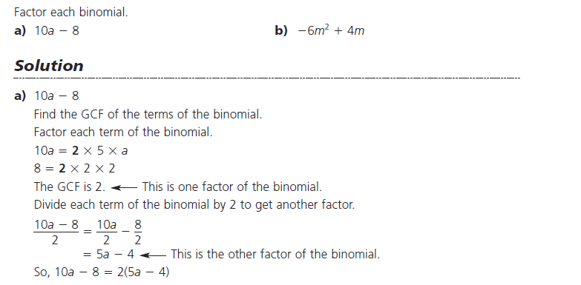

GCF Left Over Terms

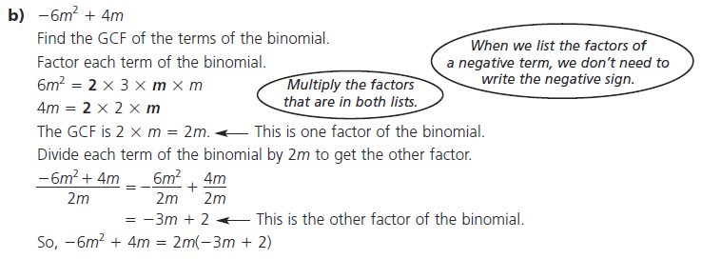

GCF Left Over Terms
Ex.2 Factor this Trinomial
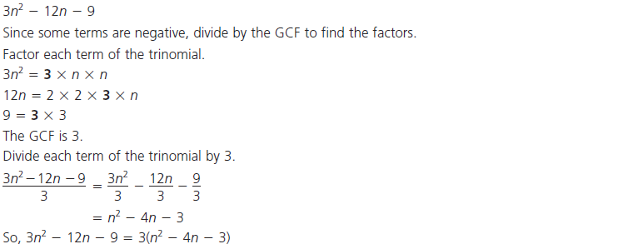

GCF Left Over Terms

Ex.3
Factor this trinomial
$-3c^{2}-15c^{4}-12c^{3}$

If all the terms are negative we factor out the negative sign too.

The GCF is therefore $-3c^{2}$

$\frac{-3c^{2}-15c^{4}-12c^{3}}{{-3c}^{2}}$

The "left over" terms are: $1+5c^{2}+4c$

So, $-3c^{2}-15c^{4}-12c^{3}$ = ${-3c}^{2}(1+5c^{2}+4c)$

GCF Left Over Terms

Do Qn's p.180 #2a(do without algebra tiles, just factor normally)
3.5 Factoring Trinomials of Form $x^{2}+bx+c$ – This is called factoring by inspection, the easy of the two methods. In general you are looking factor the Factors of "c" with also add to "b".

Ex.1
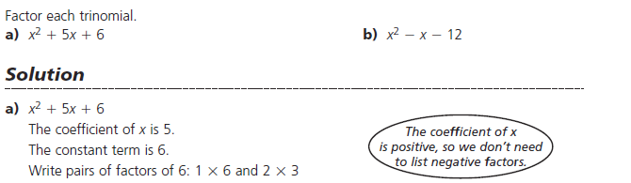

Sum 7 5

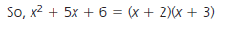
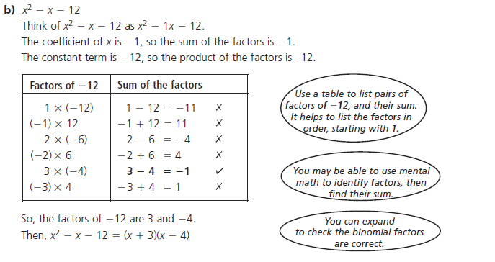

Ex.2
Factor $-4t^{2}-16t+128$, in general we should always look for a GCF first! This trinomial doesn't fit the form $x^{2}+bx+c$ but once we take out a GCF it will.

Factoring out a – 4 we are left with: $-4(t^{2}+4t-32)$

b c

We are looking for the factors of – 32 which add to +4

____ x _____ = – 32, ____ + ____= +4

c b

Because it Multiplies to a negative one # is pos. and one # is neg. and the sum is positive, so the larger # is pos.

,either listing them or thinking in your head we get – 4 and +8

So, $-4t^{2}-16t+128$ = $-4(t-4)(t+8)$

Do Qn's p.180 #6&7
3.6 Factoring Trinomials of Form ${ax}^{2}+bx+c$ – The method we use for this type of trinomial is called the decomposition method, which involves factoring by grouping pairs of binomials together.

Ex.1
Factor $6x^{2}+11x+4$

In this method we look for the factors of "a" x "c" which is 24, but these factors must sum or add to "b" which is 11.

_____ x _____ = 24 (axc)

_____ + _____ = 11 (b)
We can stop here
Factors of 24 | Sum of Factors (want 11)
1,24 | 25
-1,-24 | -25
2,12 | 14
-2,-12 | -14
3,8 | 11
-3,-8 | -11
4,6 | 10
-4,-6 | -10

To factor this trinomial we replace the middle term "11x" with the two factors we just found, but we include the variable x with it.

$6x^{2 }+11x +4$

$6x^{2}+3x+8x+4$ Then we pair off the first and last pairs and GCF each of them!

$3x\left(2x+1\right)+4(2x+1)$ Now the terms in the brackets must match, this is the "new" GCF

$(2x+1)(3x+4)$ In general we write the matching brackets (GCF) first and the "left over" terms
in front of these brackets (the 3x and +4) go second in their own bracket.

Note: answers can be checked by multiplying the two binomial brackets out.

$6x^{2}+11x+4$ $(2x+1)(3x+4)$
factor

$6x^{2}+11x+4$ $(2x+1)(3x+4)$
multiply

Ex.2
Factor $6x^{2}-21x+9$

In this example we have a common factor of 3.
So,$3({2x}^{2}-7x+3)$

In this method we look for the factors of "a" x "c" which is 6, but these factors must sum or add to "b" which is - 7.

_____ x _____ = 6 (axc)

_____ + _____ = -7 (b)

This can be done with a table, however at some point you should be able to think or the factors in your head. The Product is positive but the Sum is negative, so both factors must be negative.

So, - 1 , - 6

To factor this trinomial we replace the middle term "-7x" with the two factors we just found, but we include the variable x with it.

$3(2x^{2 }-7x +3)$ just carry the 3 down the whole way to the answer

$3(2x^{2}-6x-1x+3)$ Then we pair off the first and last pairs and GCF each of them!

To ensure the brackets match factor out a neg. from the second pair

$3[2x\left(x-3\right)-1\left(x-3\right)]$ Now the terms in the brackets must match, this is the "new" GCF

$3[\left(x-3\right)\left(2x-1\right)]$

Do Qn's p.180 #8&9
3.7 Multiplying Polynomials – In general we use the method of distribution, however terms like "FOIL" can be used for the multiplication of two binomials together or ever "feeding the chickens" can be used. Either way all the terms must multiply each other.

Prior Knowledge (adding and subtracting)
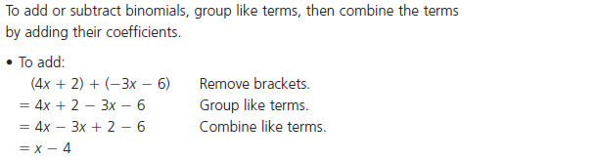
or think of this as a – 1 multiplying through the second bracket
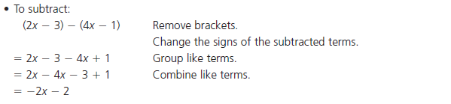
Distribution or "feeding the chickens"
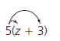
$5z+15$

Ex.1

$(x+6)(x+3)$

${ x}^{2}+3x+6x+18$

combine like terms

$x^{2}+9x+18$

Ex.2

$(2x+3)(3x-5)$

${ 6x}^{2}-10x+9x-15$

combine like terms

${6x}^{2}-1x-15$

Ex.3
Constant term out front – Start by adding a set of square bracketsaround the two binomial terms. Multiply the two binomials in the brackets first and leave the constant term out front. Last distribute the constant through.

$3(4x-1)(2x-5)$

$3[\left(4x-1\right)\left(2x-5\right)]$

$3[{8x}^{2}-20x-2x+5]$

$3[{8x}^{2}-22x+5]$

$24x^{2}-66x+15$

Do Qn's p.201 #5&6 (just expand #5, don't "draw tiles")
3.8 Factoring Special Trinomials (Perfect Square Trinomials/Difference of Squares) – Short cuts can be used to factor these types of questions, however they work for these types of questions only, so be careful when used the shortcuts.

Perfect Square Trinomials fit a pattern, notice the pattern when multiplied out. We work in reverse with factoring them.

Pattern
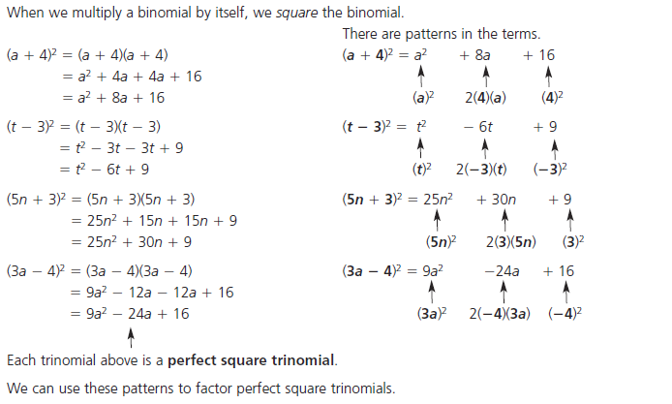
The middle term is "twice" the product
of the two terms in the original bracket.

Ex.1
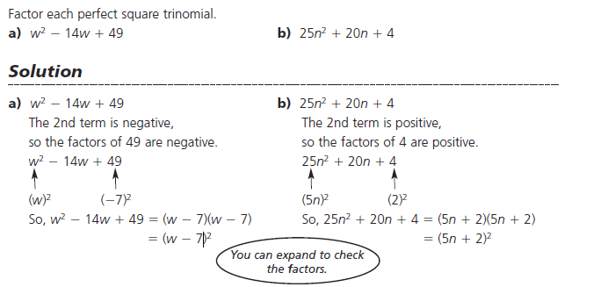

Notice the middle sign of the perfect square trinomial matches that of the answer.

Difference of Squares fit a pattern too, the two terms in the question are both perfect squares and the sign between them must be a negative or "difference".

Pattern
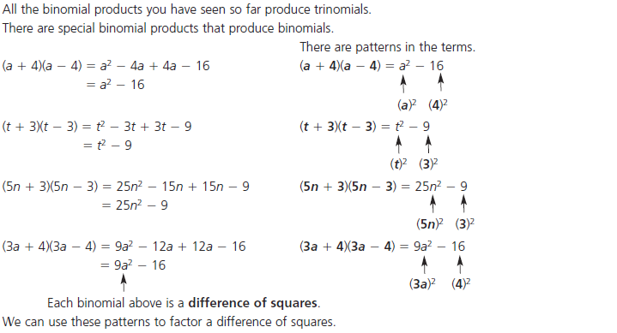
Ex.1
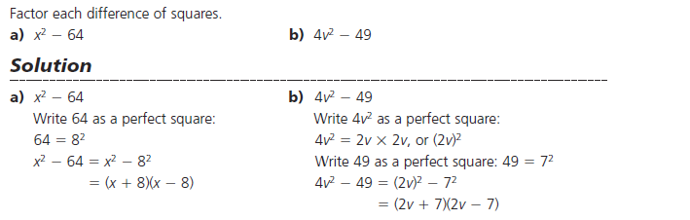

The factored answer is always a plus and minus sign.

Do Qn's p.201 #7

