**Chp 4 Roots and Powers (Radicals and Exponents)**

**4.2 Rational and Irrational Numbers**

**NATURAL NUMBERS (N) INTEGERS (I)**

*Example:1,2,3,4…* **WHOLE NUMBERS**  *Example:…-2,-1,0,1,2…*

*Example:0,1,2,3…*

IRRATIONAL NUMBERS ($\overline{Q}$) RATIONAL NUMBERS (Q)

1) ***when converted to decimal form they are:*** 1) ***numbers that can be written *nonterminating and in fraction form. A quotient of***

***\*non–repeating integers***

***therefore they cannot be written as fractions*** 2) ***as radicals they DO have exact roots***

2) ***as radicals they DON"T have exact roots*** 3) ***when converted to decimal form***

***they:***

***\*terminate(end) or***

\****repeat (pattern)***

*Examples: Examples:*

$π$ = 3.1415… -5 =

$\sqrt{2}$ = 1.41421… 0.25= $\sqrt[3]{5=}$ 1.7099… = 3

0. =

- 2 =

5

= 4

# REAL NUMBERS

-*all numbers that can be expressed in decimal form*



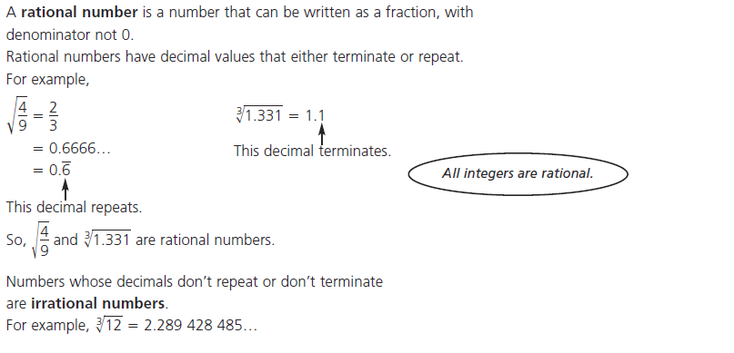

**Ex.1**

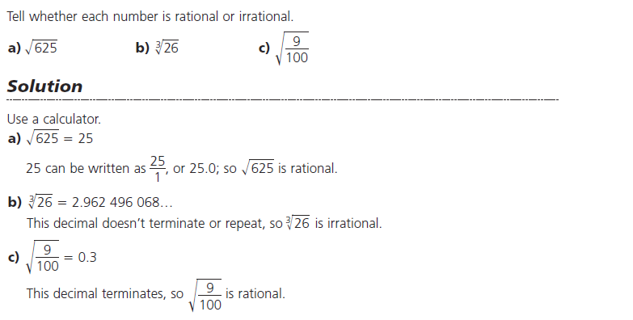

**Ex.2**

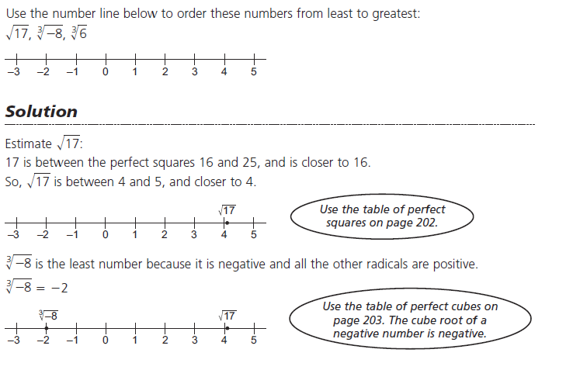

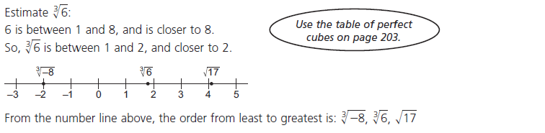

Perfect Square Numbers and Perfect Cube Numbers are used a lot in this chapters, so you should know most of them from memory. I should know the perfect square numbers up to ${12}^{2}=144$, and the perfect cubes up to at least $4^{3}=64.$

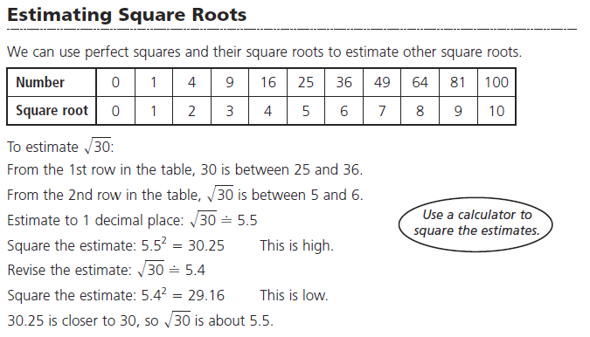

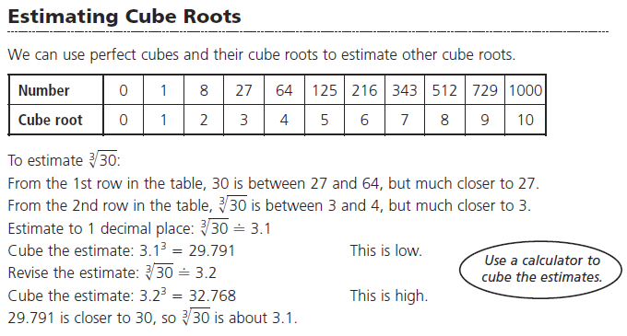

*Do Qn's p.221 #1-5*

**4.3 Mixed and Entire Radicals** – Again you need to know your perfect Square/Cube numbers from memory. Most of these questions are considered to be "non-calculator questions".

**Ex.1** Entired to Mixed Radicals

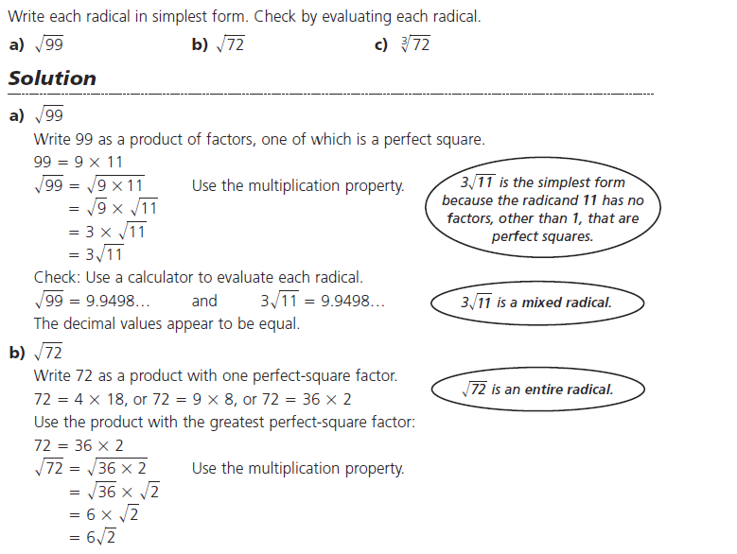

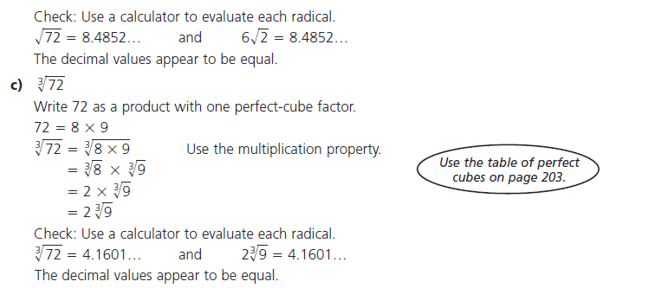

**Ex.2**

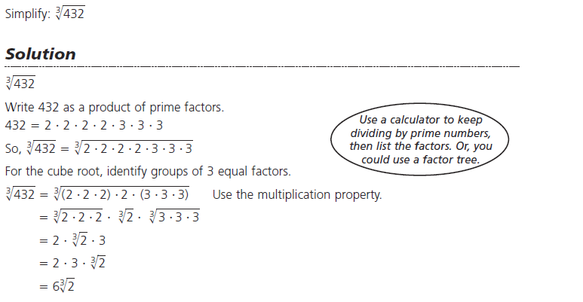

**Mixed to Entire Radicals**

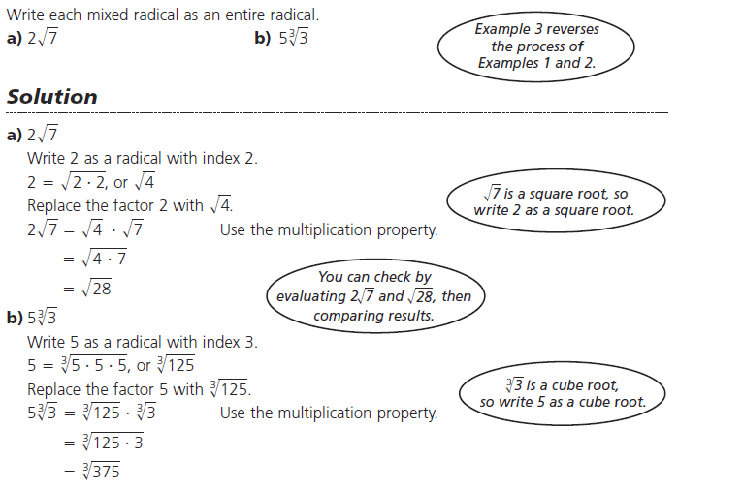

*Do Qn's p.221 #9&11*

**4.4 Fractional (Rational) Exponents and Radicals –** Roots can be written as Radicals and vice versa.

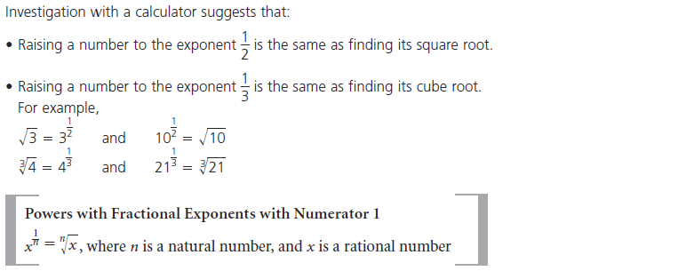

**Ex.1**

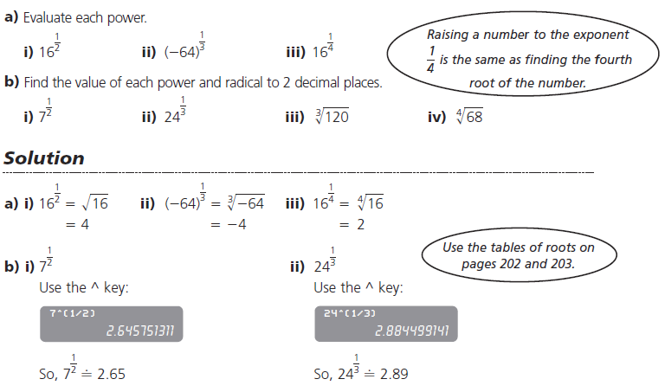

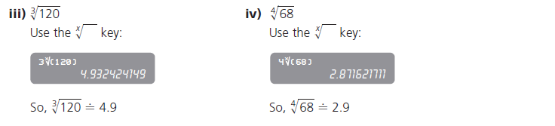

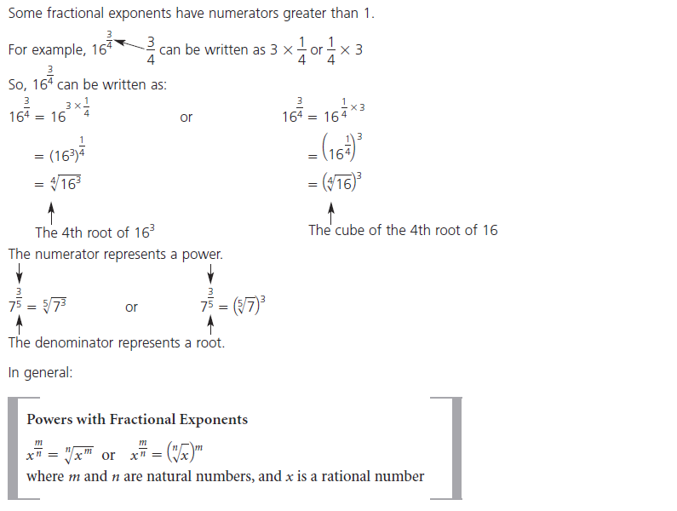

Writing Fractional Exponents as Radicals

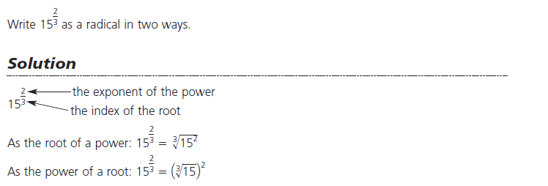

**\*Preferred Method\***

Writing Radicals as Exponents

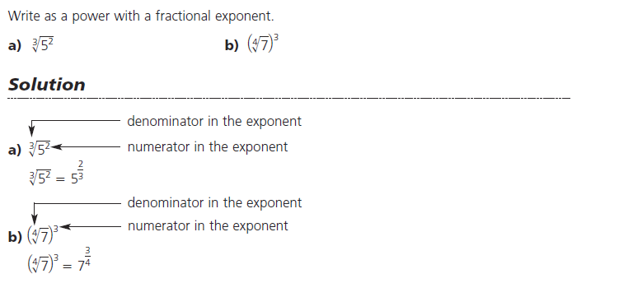

**Ex.2**



**Ex.3** Evaluating Radicals and Powers (without a calculator)

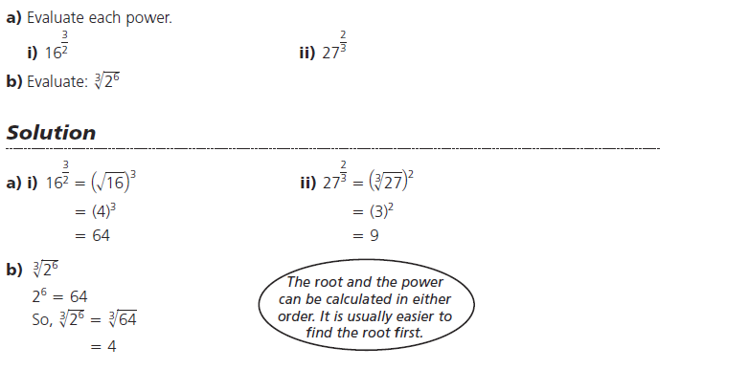

*Do Qn's p.236 #1-3*

**4.5 Negative Exponents and Reciprocals**

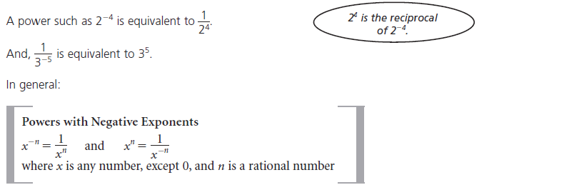

**Ex.1** Evaluating Exponents with Negative Integers

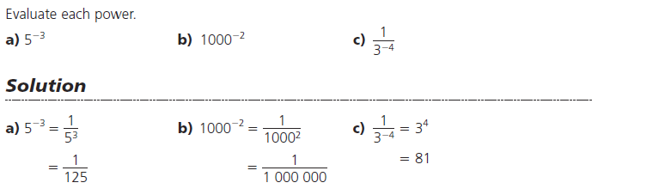

**Ex.2** Evaluating Exponents with Negative Fractional (Rational) Exponents

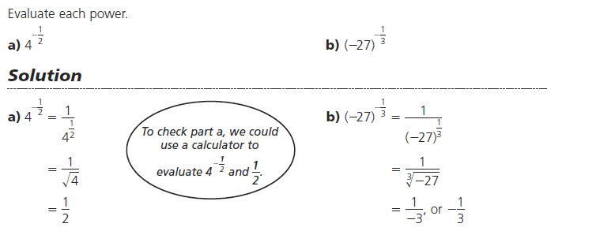

**Ex.3**

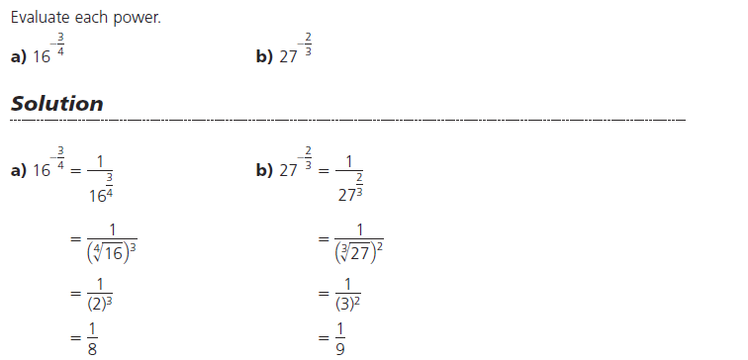

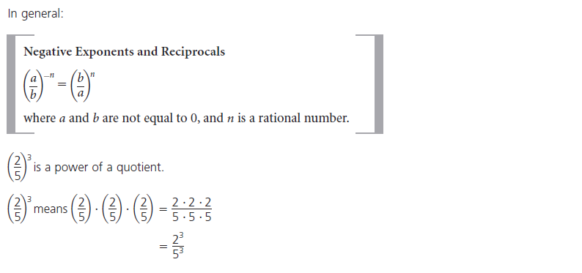

**Ex.4**

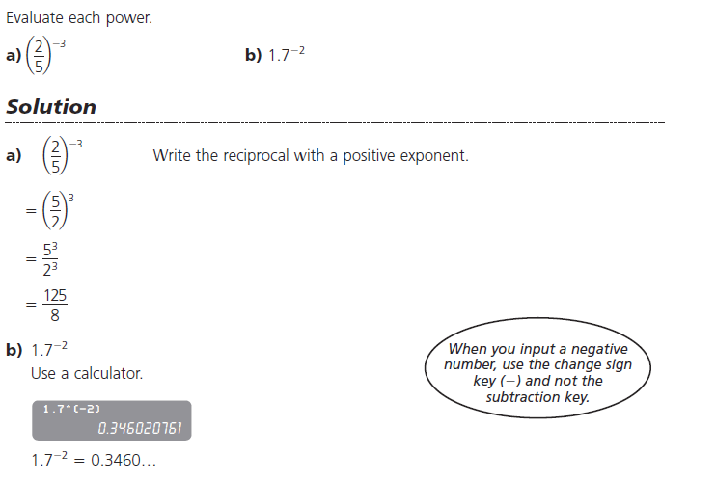

Or ${1.7}^{-2}$

$\frac{1}{{1.7}^{2}}=0.3460…$

*Do Qn's p.236 #7&8*

**4.6 Applying the Exponent Laws**

Prior Knowledge

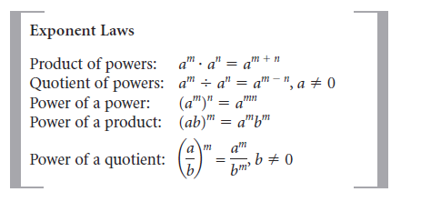

**Ex.1**

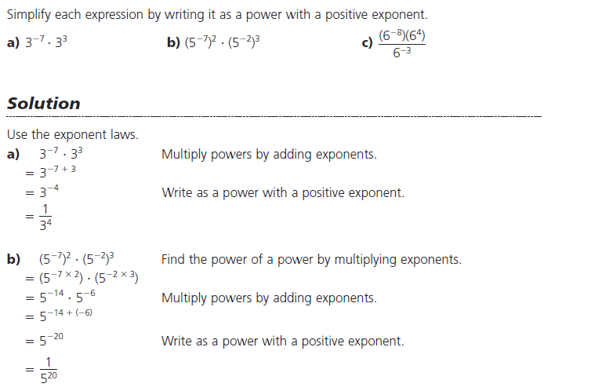

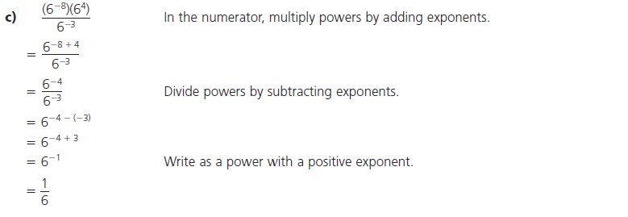

**Ex.2**

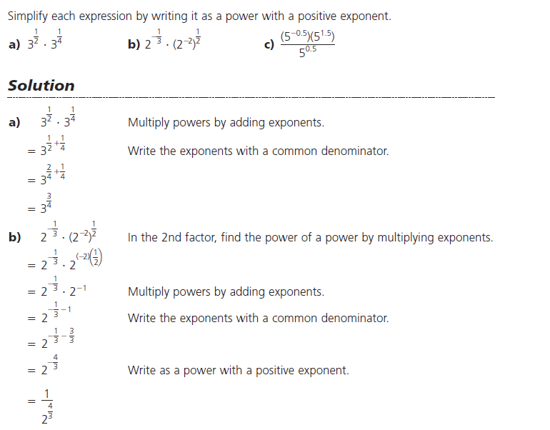

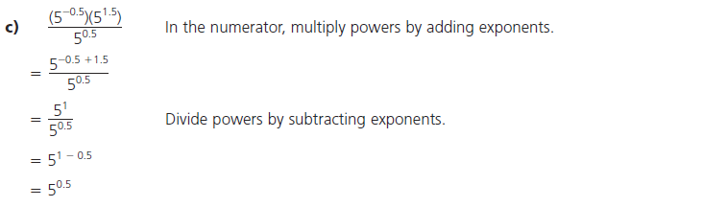

Or $=5^{\frac{1}{2}}$

**Ex.3**

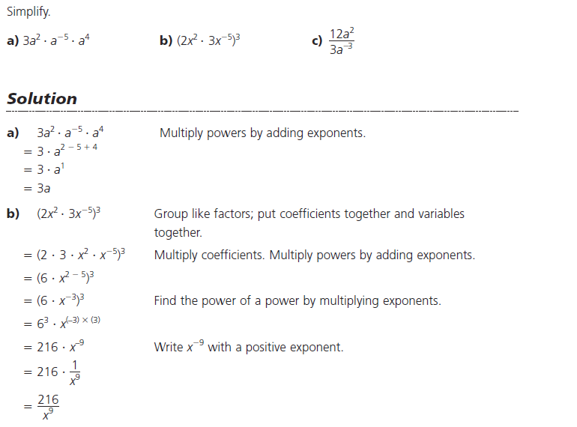

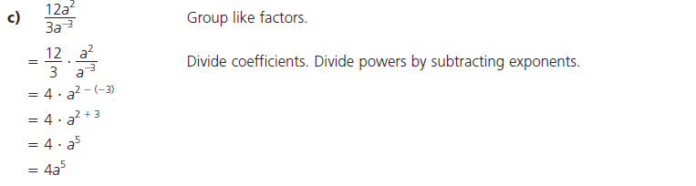

**Ex.4**

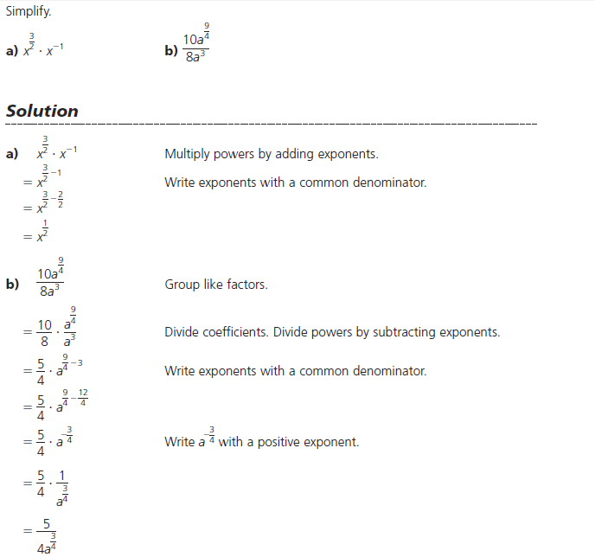

*Do Qn's p.249 #6&7*

**Chp 4 Study Guide**

