Chp 5 Relations and Functions

5.1 Representing Relations
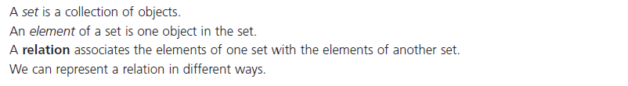

Ex.1 Representing a relation given in a Table
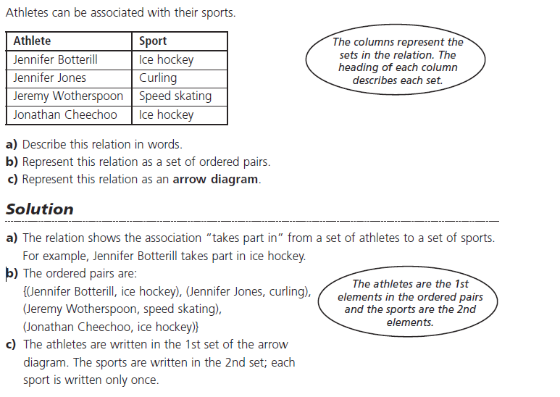
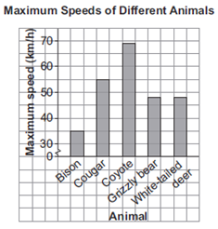
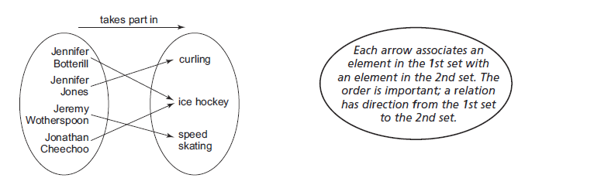

Ex.2 Representing a Relation given as a Bar Graph
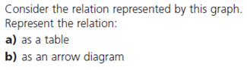
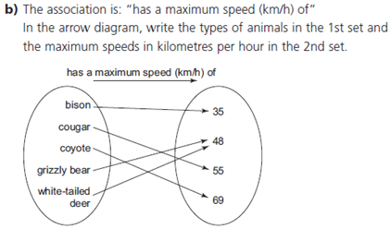
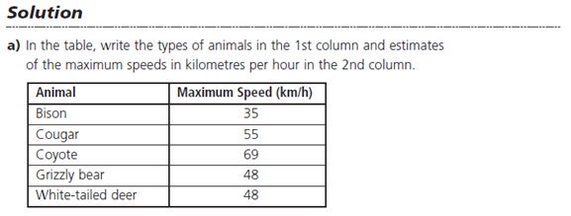

Do Qn's p.275 #1

5.2 Properties of Functions

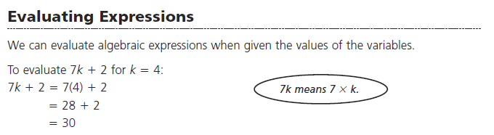
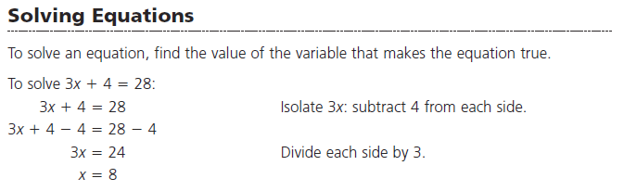

Domain of a function are the "inputs" or the "x-values" which a function can have.
Range of a function are the "outputs" or "y-values" which a function can have.

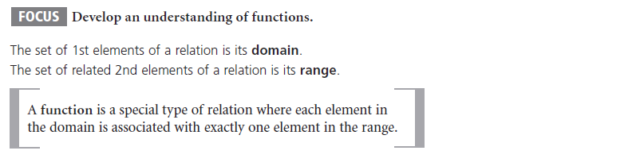
Ex.1 Identifying Functions
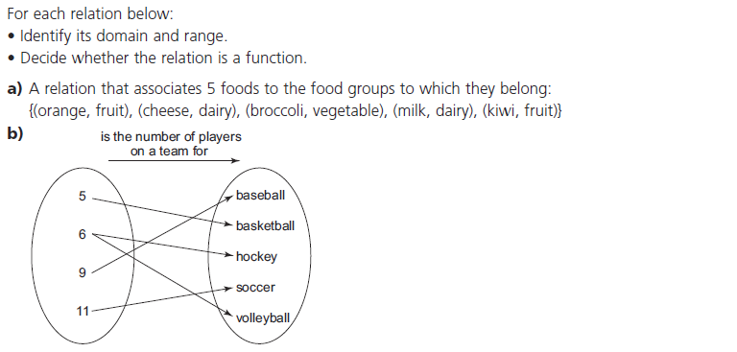

Input or "x-values" Output or "y-values"
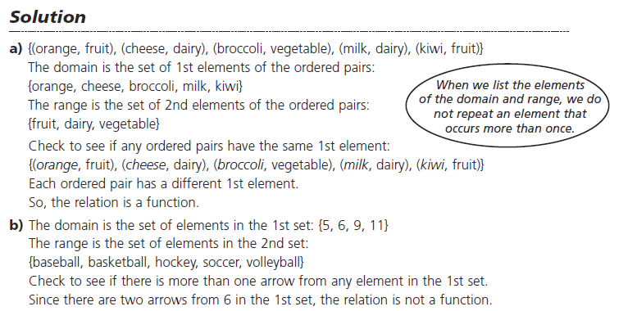
Ex.2 Describing Functions
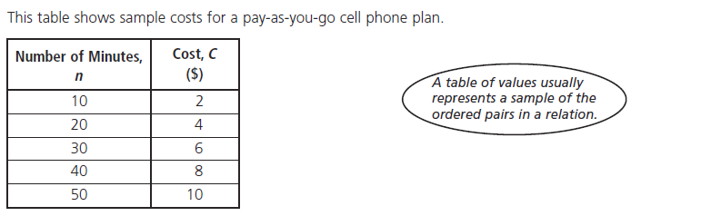

Input or "x-values" Output or "y-values"
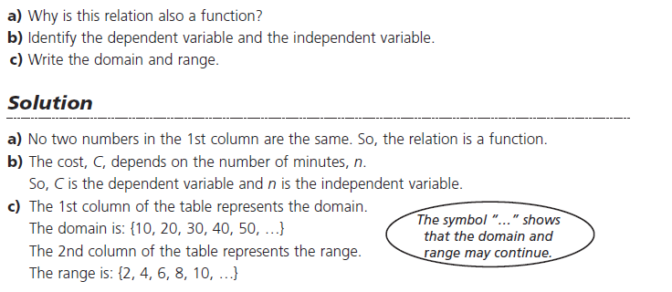

Ex.3 Using Function Notation to Find Values
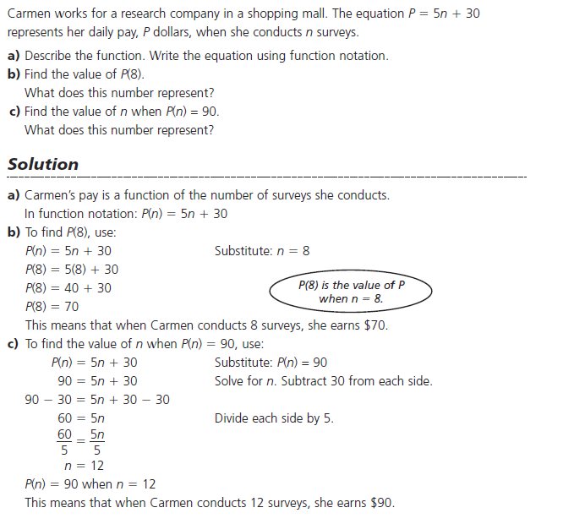
Do Qn's p.275 #2-4
5.3 Interpreting and Sketching Graphs

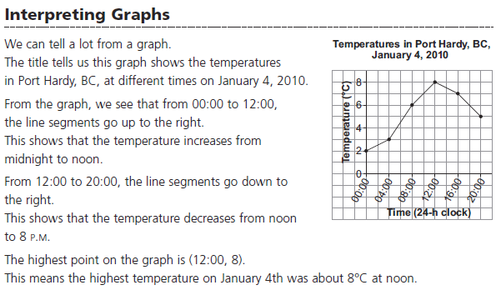

Ex.1 Interpreting a Graph

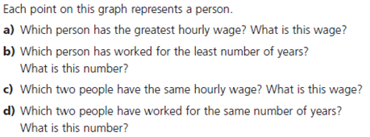
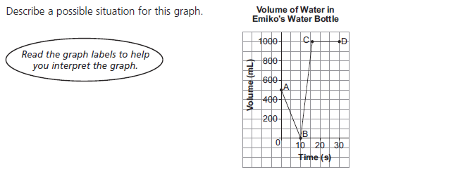
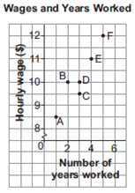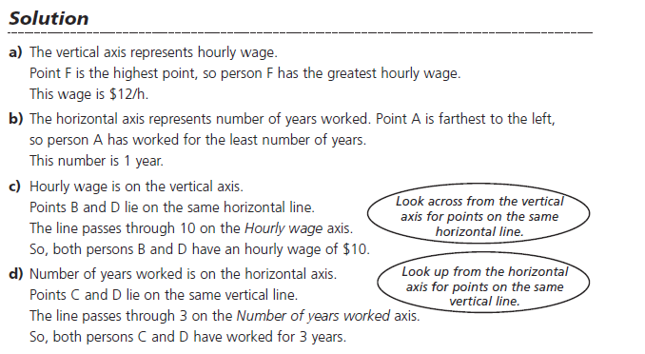
Ex.2 Describing Graphs

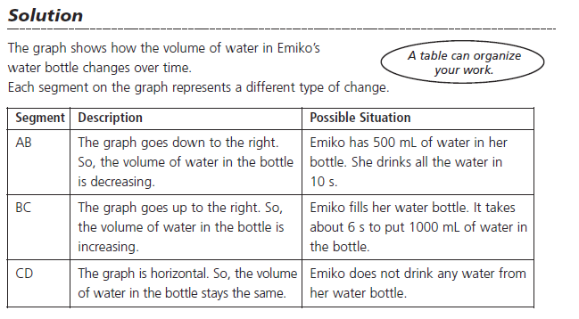
Do Qn's p.299 #1
5.5 Graphs of Relations and Functions
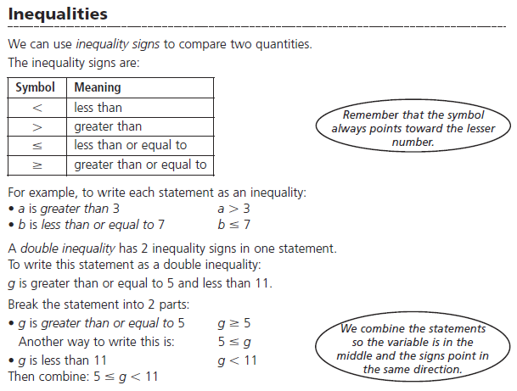

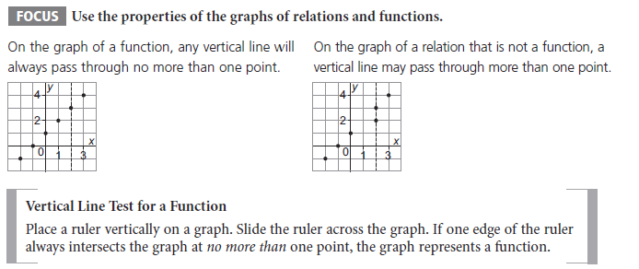

Ex.1 Identifying the Graph of a Function
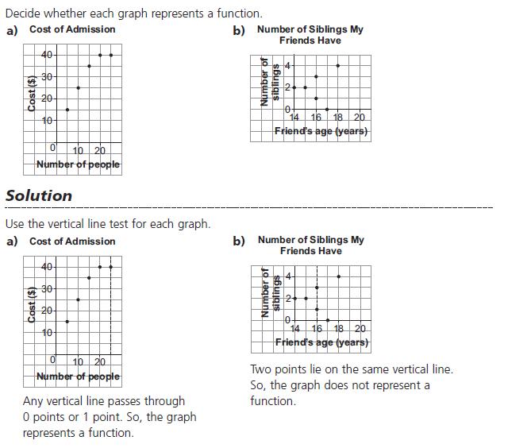
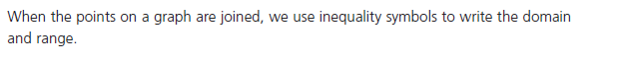
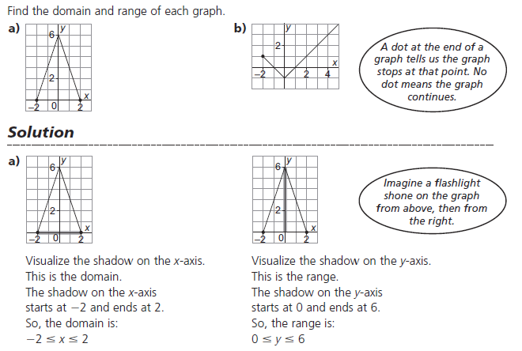

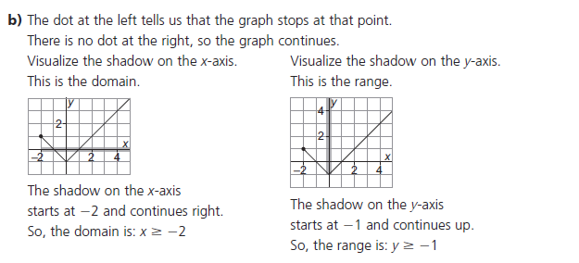
Ex.3 Finding Values from the Graph of a Function
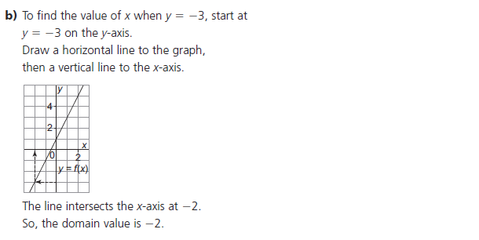
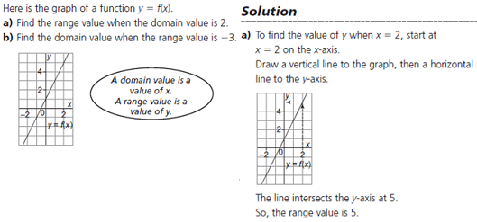
Do Qn's p.299 #3

5.6 Properties of Linear Functions
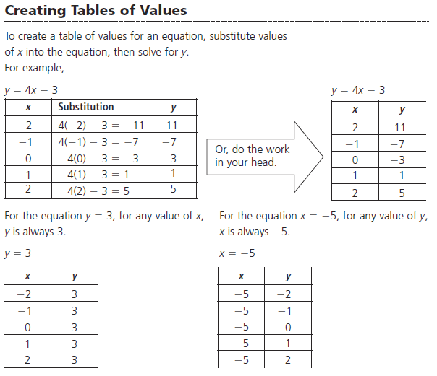

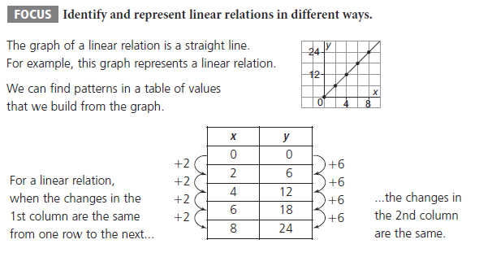
Ex.1 Deciding if a Table of Values Represents a Linear Relation
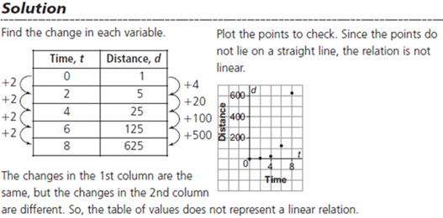
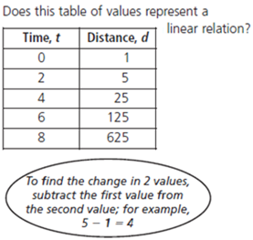

Ex.2 Deciding if an Equation Represents a Linear Relation
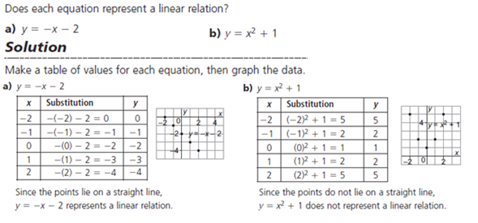

Slope or Rate of Change
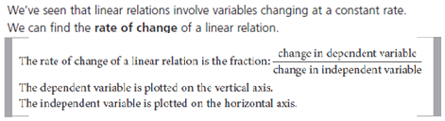
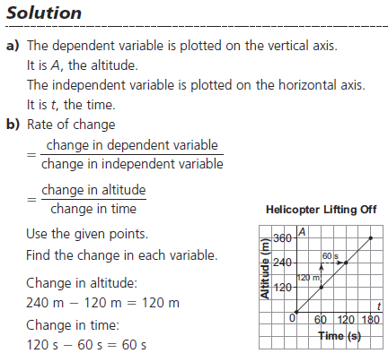
Ex.3 Finding the Rate of Change of a Graph
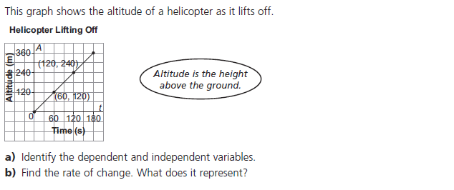

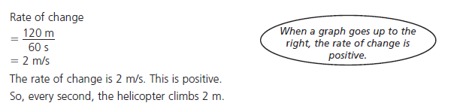

Do Qn's p.308 #3&5

5.7 Interpreting Graphs of Linear Functions

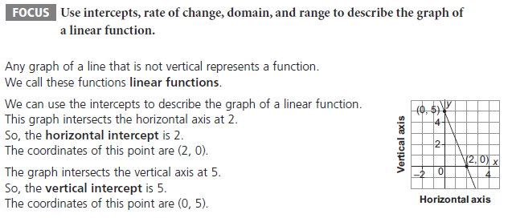

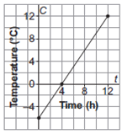
Ex.1 Finding Intercepts, Domain, and Range of a Function
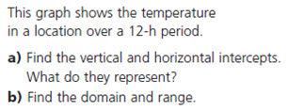

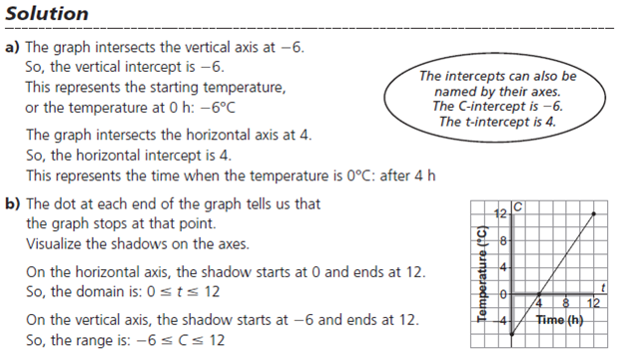
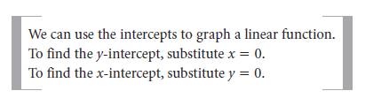
Ex.2 Sketching a Graph using Intercepts
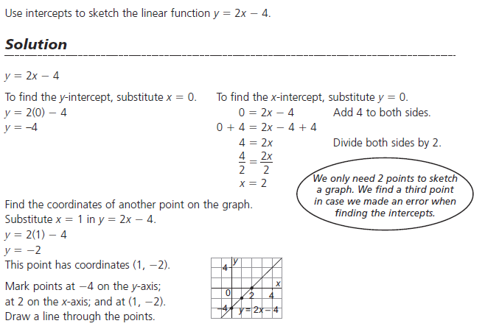

Ex.3 Matching a Graph to a Given Rate of Change (Slope) and Vertical Intercept (y-intercept)
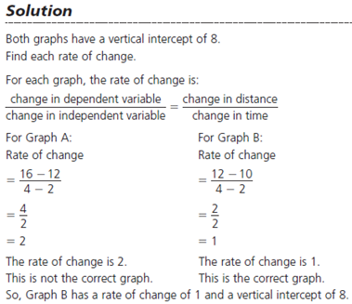
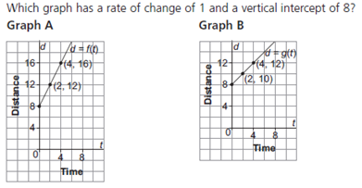
Do Qn's p.319 #4&8

