Chp 6 Linear Functions

6.1 Slope or Rate of Change
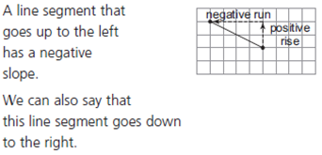
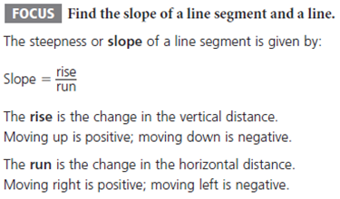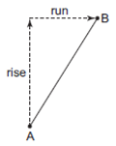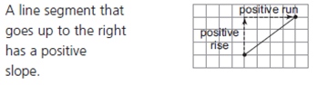
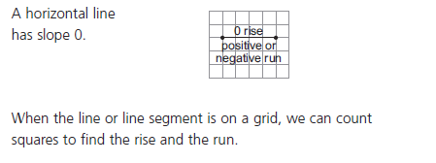

Ex.1 Finding the Slope of a Line Segment
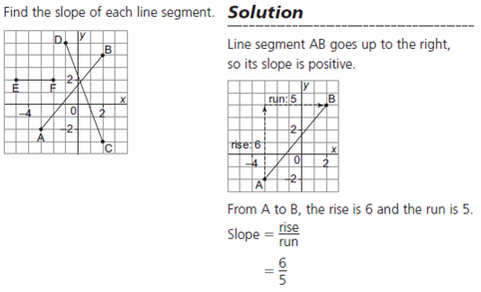
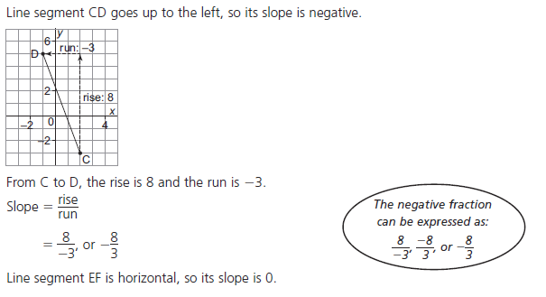

Ex.2 Drawing a Line Segment Given a Slope
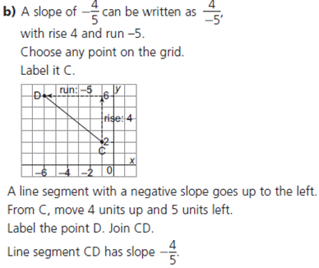
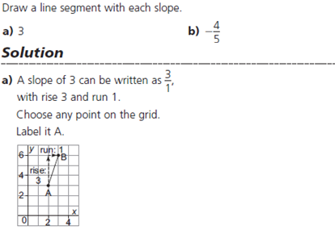
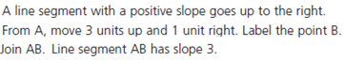

Ex.3 Finding Slope Using Two Points on a Line
Use the "marked" points on the graph which cross at exact values.
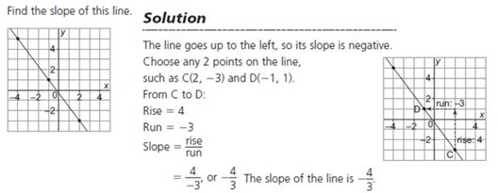

Use the Slope equation in the form of;
Slope = y₂ – y₁
x₂ – x₁

Label the Points

(x₁ , y₁) (x₂ , y₂) Use bracket for the second terms to prevent sign errors

Slope = 1 – ( - 3) = 1+3 = 4 =_ 4
-1 – (2) -1 – 2 - 3 3

In general keep the neg. sign in front
Ex.4 Slope Calculations
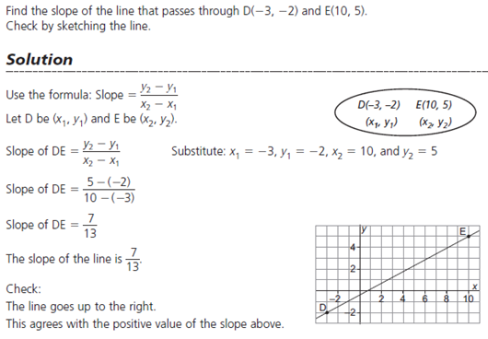
What slope Signs Mean
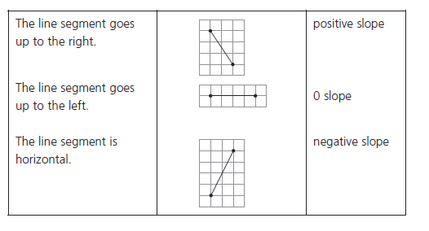
Do Qn's p.353 #1,2,4

6.2 Slopes of Parallel and Perpendicular Lines
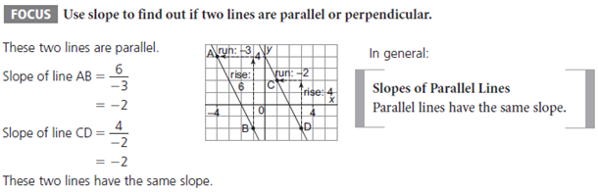
Ex.1 Identifying Parallel Lines
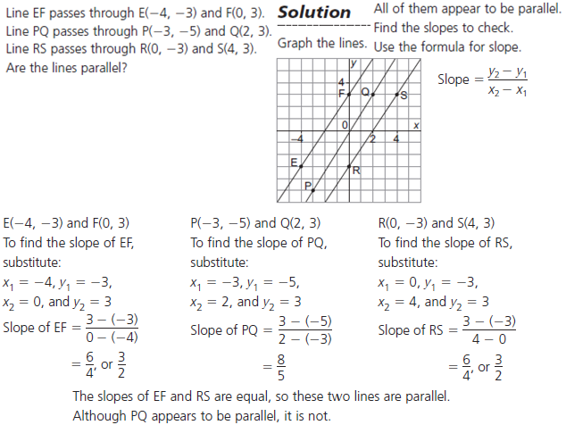
Ex.1b Identifying Perpendicular Lines

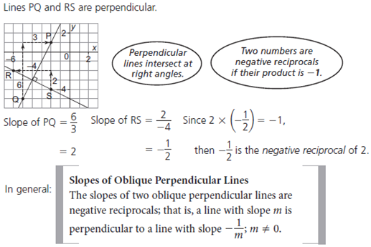

Ex.2 Examining Slopes to Compare Lines
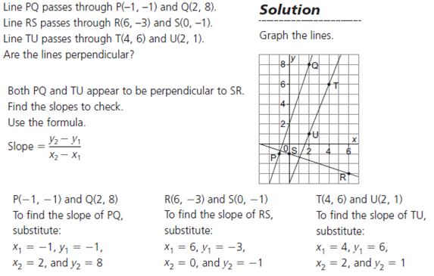
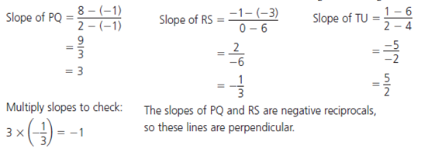
Do Qn's p.353 #5,7,8
6.4 Slope – Intercept Form – is the easiest and most commonly used method to graph a linear function.

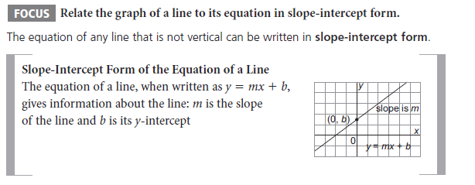
Ex.1 Writing an Equation given the Slope and y-intercept

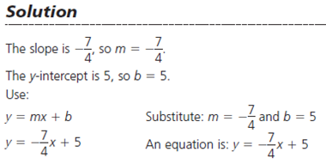

Ex.2 Graphing a Line given in Slope-Intercept Form
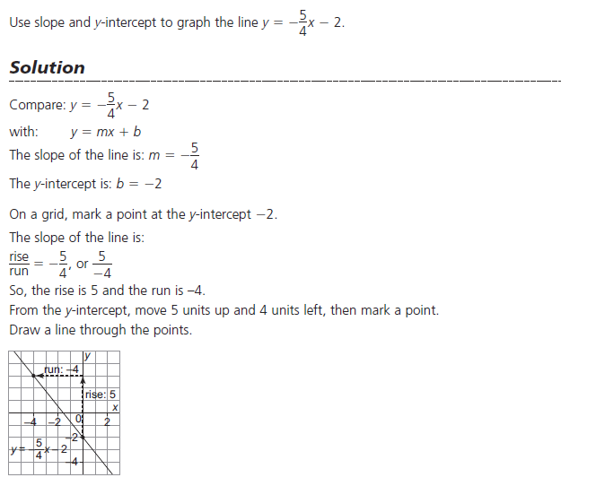
Ex.3 Writing an Equation given a Graph
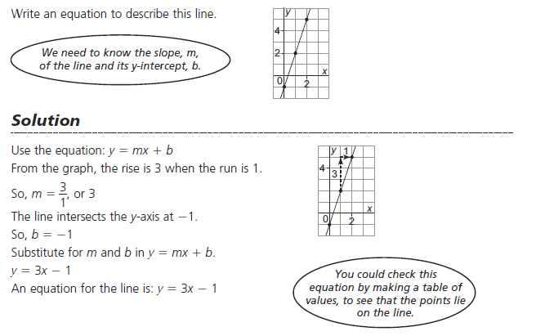
Do Qn's p.376 #2
6.5 Slope – Point Form
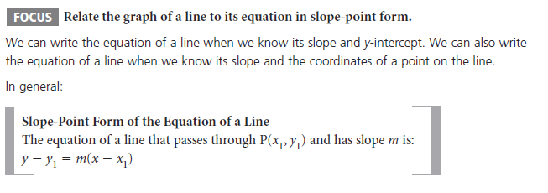
Ex.1 Graphing a Line given an Equation in Slope – Point Form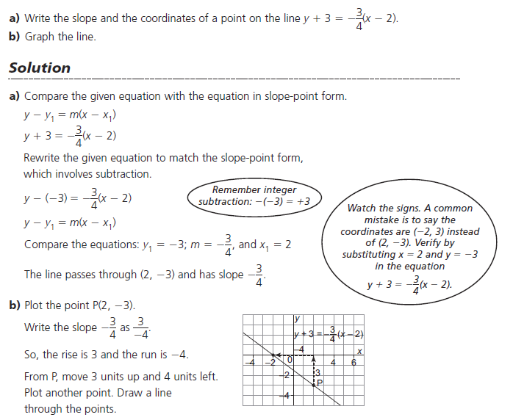
Ex.2 Writing an Equation in Slope- Point Form given a Graph

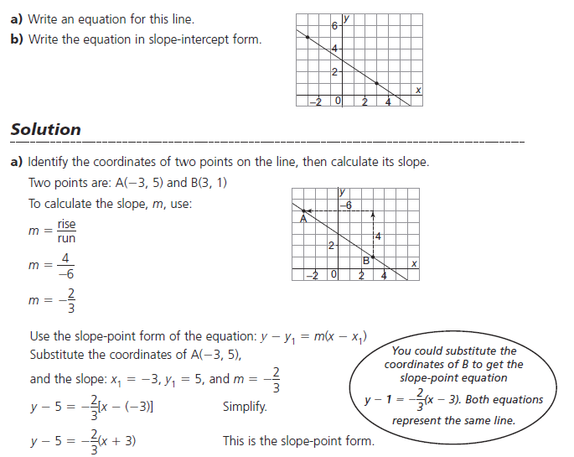
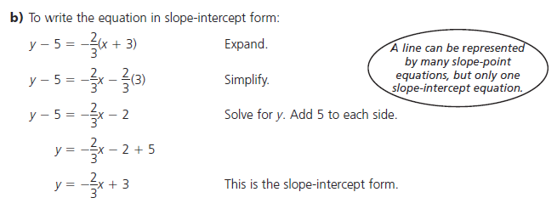
Ex.3 Writing an Equation of a Line which is Parallel to a given Line

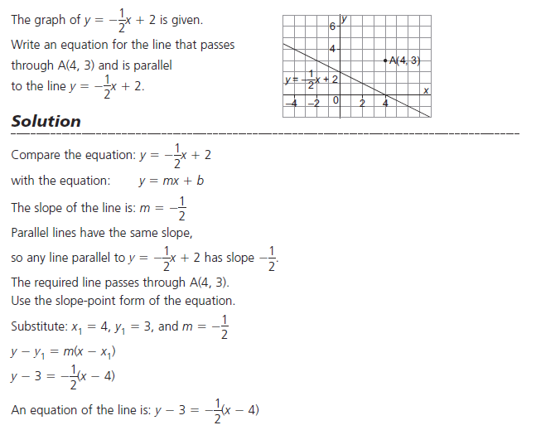
Do Qn's p.376 #3&4
6.6 General Form for Linear Relations – general form is more of a starting or ending point for a question. It tells us very little about the line itself, with the exception of graphing using the x&y intercepts.

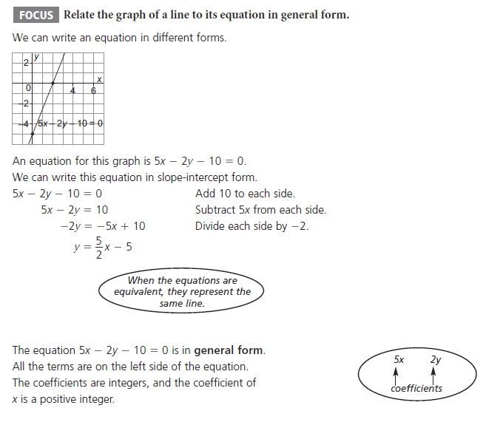
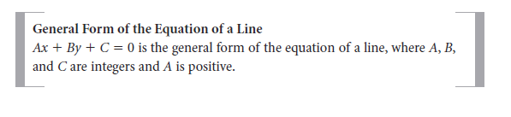
Ex.1 Writing an Equation in General Form

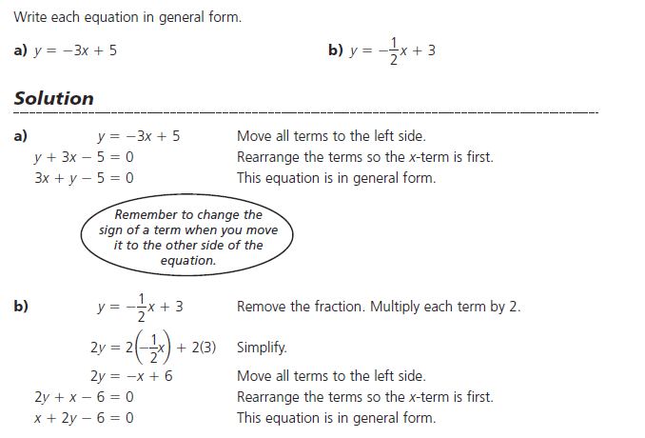
Ex.2 Finding the slope of a Line given in General Form
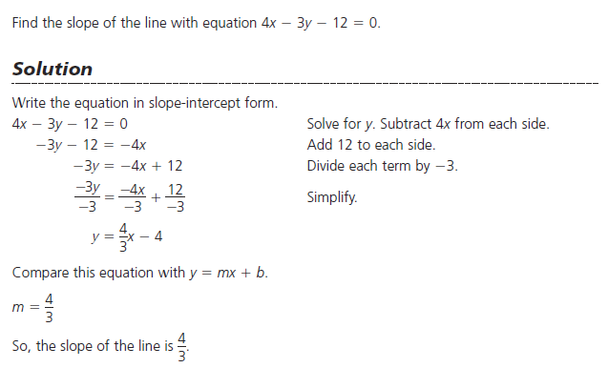

Ex.3 Using Intercepts to Graph a Line in General Form

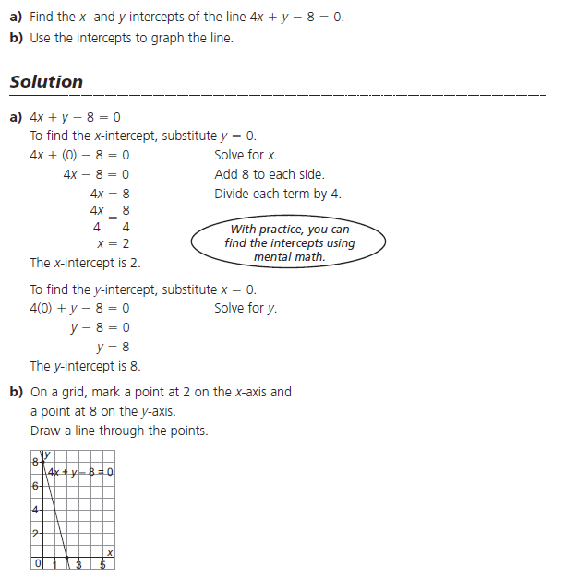

Do Qn's p.384 #6&9
Chp6 Study Guide

