Chp 7 Systems of Linear Equations

7.1 Developing Systems of Linear Equations
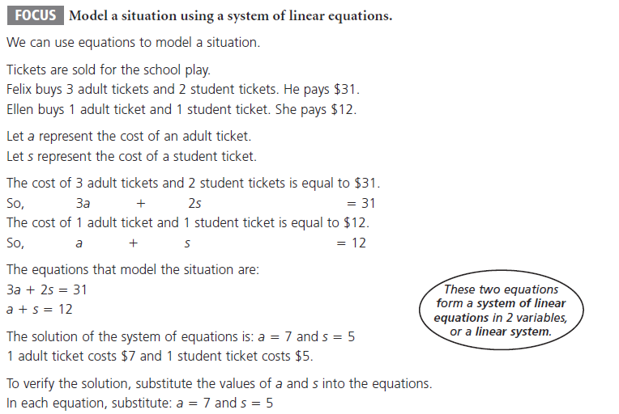
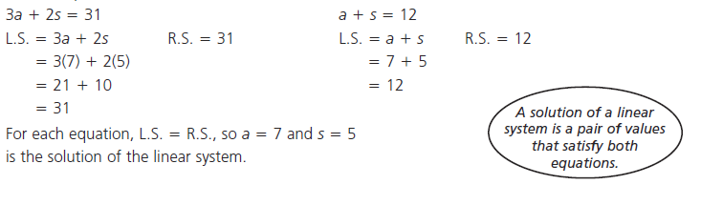
Ex.1 Identifying the Corre3ct Solution to Linear Systems (where the two lines cross)
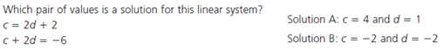
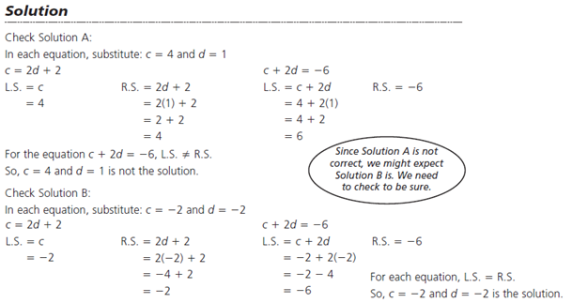

Ex.2 Using a Table to Create a Linear System
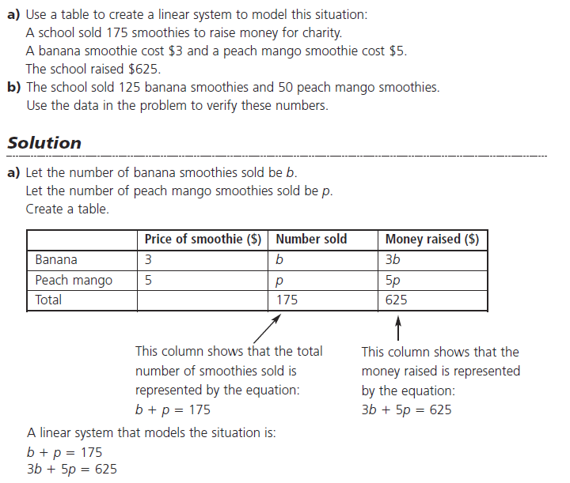
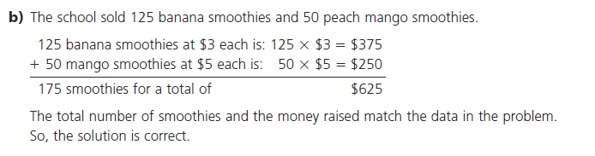
Do Qn's p.415 #1&2
7.2 Solving a System of Linear Equations Graphically
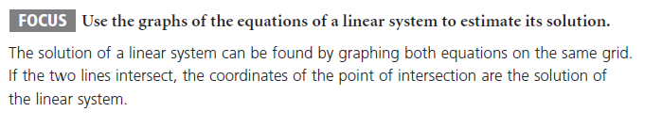

Ex.1 Solving a Linear system by Graphing
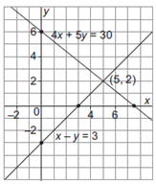
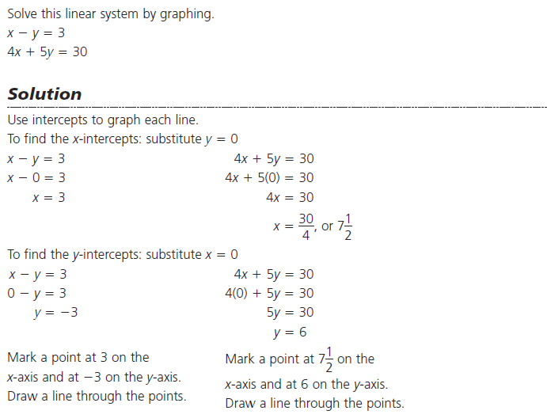
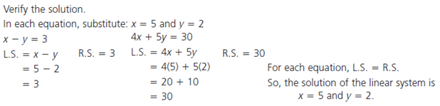

Ex.2 Solving a Word Problem by Graphing a Linear System
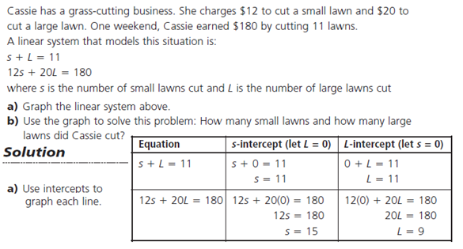
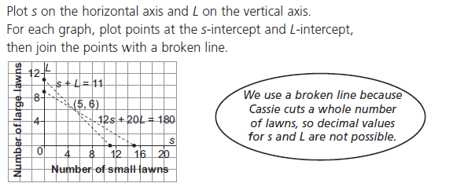
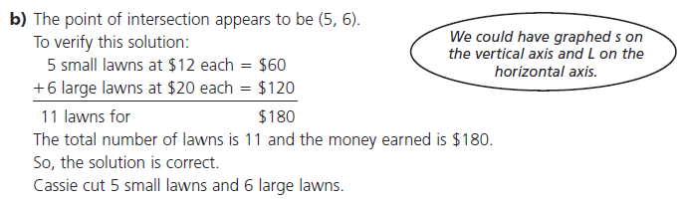
Do Qn's p.415 #3&4
7.4 Solving Linear Systems by Substitution

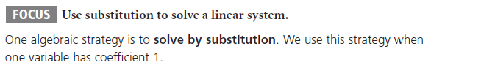

Ex.1 Solving a System by Substitution

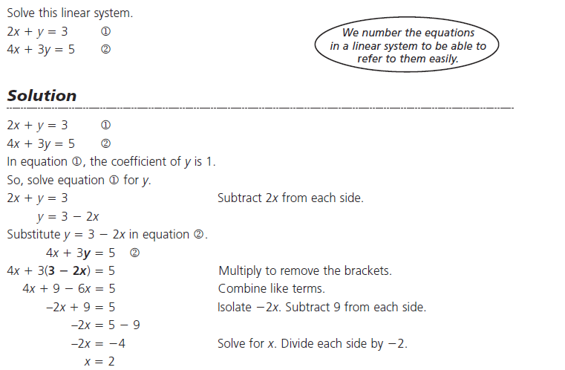
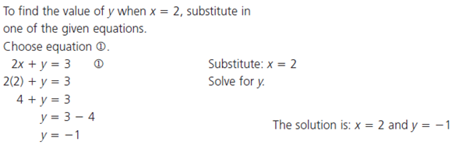
Solutions can be verified by substituting the answer back into the original equations, the solution must satisfy both equations for it to be correct.
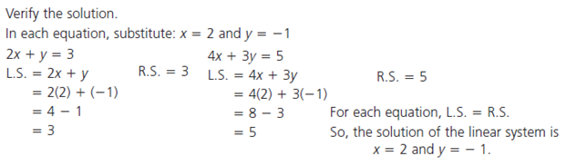
Ex.2 Using Substitution to Solve a Word Problem
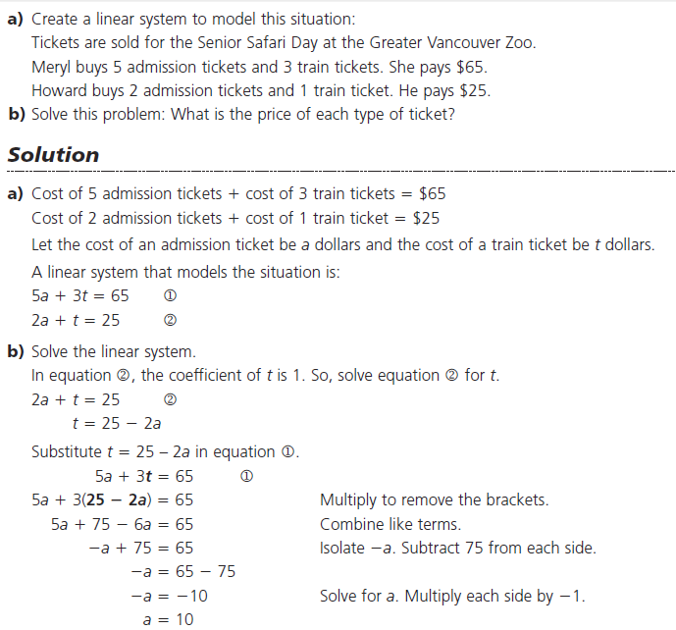
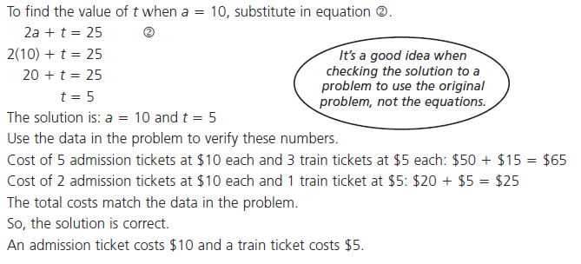
Do Qn's p.441 #1&3
7.5 Solving Linear Systems by Elimination

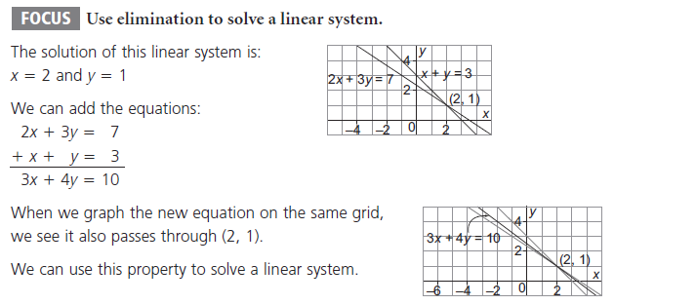
Ex.1 Solving a Linear System by Adding to Eliminate a Variable
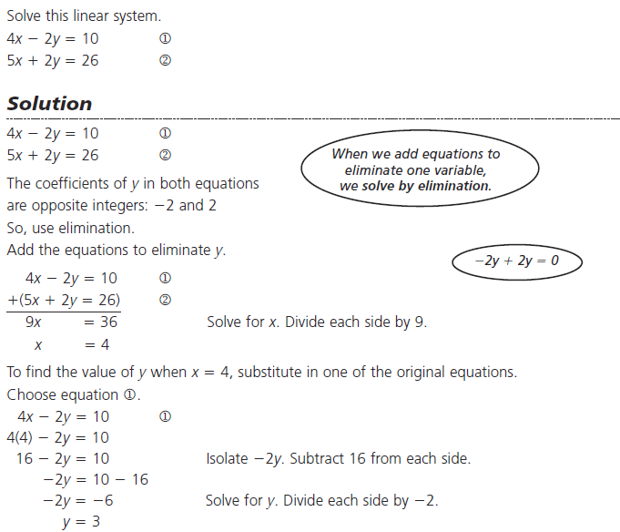

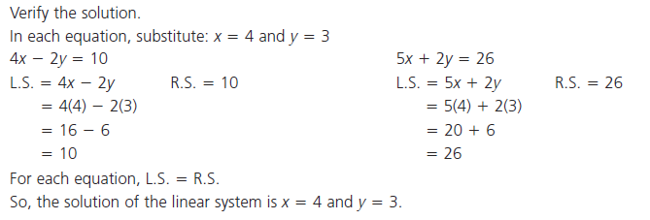
Ex.2 Solving a Linear System by Multiplying to Change a Co-efficient
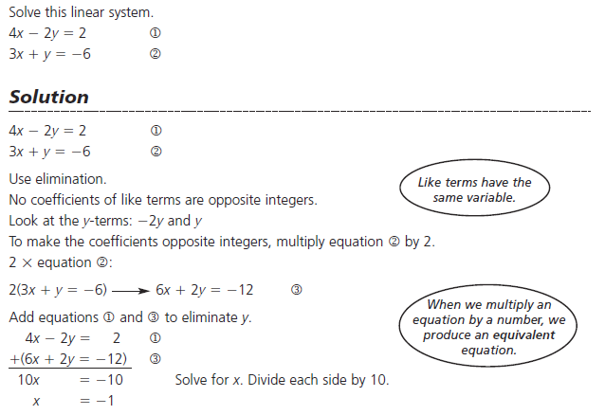
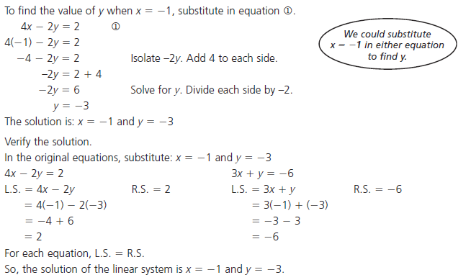

Ex.3 Using Elimination to Solve a Word Problem
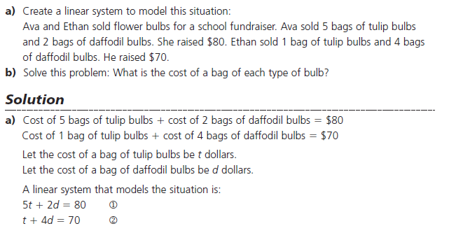
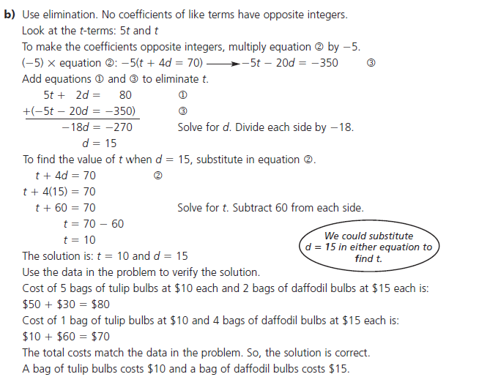
Do Qn's p.441 #4-6
7.6 Properties of Systems of Linear Equations (number of solutions to a system)
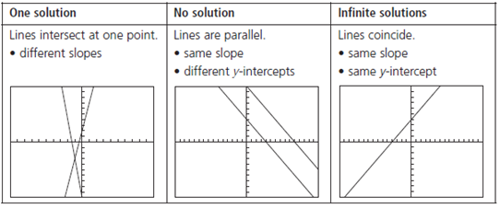
Ex.1 Finding the number of Solutions to Linear Systems
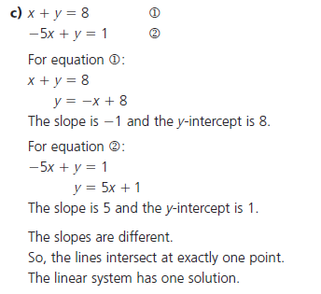
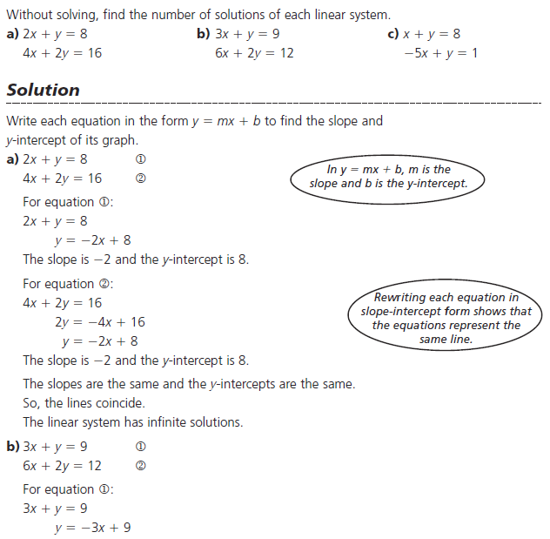
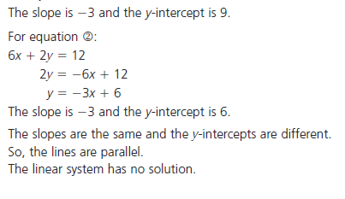

Do Qn's p.448 #7

Chp 7 Study Guide

