5.1-Working with Radicals

Simplifying, Adding and Subtracting

Entire Radicals: Mixed Radicals:

In general, $m\sqrt[x]{y}+n\sqrt[x]{y}=(m+n)\sqrt[x]{y}$.

*m* and *n*:_______________, *x*:________________, *y*:________________

**Perfect Square Numbers:** we __________ take an **even root** of a negative radicand

**Perfect Cube Numbers:** we __________ take an **odd root** of a negative radicand.

Express each radical as a **mixed** radical.

$\sqrt{200}$ $\sqrt[3]{24}$ $\sqrt{x^{2}}$ $\sqrt{x^{3}}$ $\sqrt[3]{x^{7}}$

$\sqrt{12x^{5}y^{3}}$ $3\sqrt[3]{24x^{8}y^{5}}$

Convert each radical to an **entire** radical.

$3\sqrt{2}$ $-2\sqrt{5}$ $x^{3}\sqrt{x^{3}}$

When adding or subtracting radicals, combine the ___________________ of **like** radicals.

$7x+5x=$ $7\sqrt{3}+5\sqrt{3}=$ $7\sqrt{x}+5\sqrt{x}=$

**Simplify** and **combine like terms** in the following expressions.

$2\sqrt{7}+13\sqrt{7}$ $3\sqrt{2}+3\sqrt{8}$ $2\sqrt{40}+\sqrt{90}$

$\sqrt{80}+2\sqrt{5}+\sqrt{20}-\sqrt{12}$ $4\sqrt{32x^{2}}-2\sqrt{18x^{4}}$

$\sqrt[3]{24}+\sqrt[3]{81}+\sqrt[3]{16}$ $3\sqrt[3]{8x^{2}y^{6}}-x\sqrt[3]{x^{5}}+y\sqrt[3]{125x^{2}y^{3}}$

HW: p 278 Questions: 1-3, 5(express answers as mixed radicals), 8acd, 9ab, 10ab, 17

Ignore the restriction on the variables in the radicand, we will do this in 5.3 graphing radical equations.

5.2-Working with Radicals pt 1

Multiplying

When ***multiplying*** radicals: multiply the ***coefficients*** together and multiply the ***radicands*** together. Then simplify the ***radicand*** where possible.

Note that you can only multiply radicals if they have the ***same index.***

$\sqrt{3}∙\sqrt{3}=\sqrt{ }=$ $2\sqrt[3]{x}∙3\sqrt[3]{x^{4}}=$

Expand the radical expression $\left(4\sqrt{7}\right)\left(4\sqrt{75}\right)$

Expand $7\sqrt{3} \left(5\sqrt{5}-6\sqrt{3}\right)$ Expand $\left(8\sqrt{2}-\sqrt{5}\right)\left(9\sqrt{5}+6\sqrt{10}\right)$

${\left(3\sqrt{3x}-2\sqrt{8x^{2}}\right)}^{2}$ $\left(3\sqrt{3}-2\sqrt{2}\right)\left(4\sqrt{5}+\sqrt{2}\right)+3\sqrt{3}\left(3\sqrt{3}-\sqrt{2}\right)$

$(2\sqrt{7}+4\sqrt{2})∙(2\sqrt{7}-4\sqrt{2})∙\left(3\sqrt{5}+\sqrt{6}\right)$

HW: p 289 Questions: 1*abce*, 2*abd*, 3*ac*, 4abc, 5

5.2-Working with Radicals pt 2

Dividing

When ***dividing*** radicals: divide/reduce the ***coefficients*** together and divide/reduce the ***radicands*** together.

You can only divide radicals that have the ***same index***.

Then you **MUST** ***rationalize*** the denominator (the denominator must be a ***positive whole number, not a radical***).

Simplify by rationalizing the denominator:

$\frac{5}{\sqrt{3}}$ $\frac{5}{2\sqrt{7}}$ $\frac{4\sqrt{30}}{16\sqrt{15}}$

$\frac{4\sqrt{5}}{28\sqrt{10}}$ $\frac{2\sqrt[3]{4}}{3\sqrt[3]{12}} \frac{\sqrt{21x^{5}y^{2}z}}{\sqrt{7x^{3}y^{5}z}}$

When the denominator is a ***binomial*:**rationalize the denominator using the ***conjugate*** (the same ***two*** terms separated with ***opposite signs***).

HW: p 289 Questions: 6, 7b, 8ab, 10, 11ab

$\frac{2}{4+\sqrt{5}}$ $\frac{2}{3-\sqrt{10}}$

$\frac{4}{2-\sqrt{8}}$ $\frac{2}{6+\sqrt{6}}$

5.3-Graphing Radicals

Think back to chapter 3. We initially learned how to graph quadratics using ___________________ form. The equations for this type of formula was written as ________________________. This chapter focuses on radicals, the basic form of this type of functions is written ________________________.

$$y=a (x-p)^{2}+q$$

$$y=a\sqrt{(x-h)}+k$$

Transformation of a radical function follows the same principals of that of a quadratic function.

‘a’:___________________________________

‘h’: __________________________________

‘k’: __________________________________

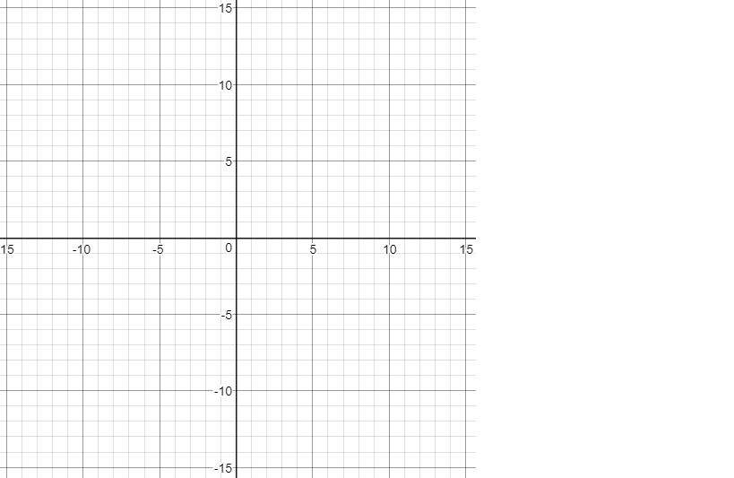*"Average Joe" or base y-values*

*a = 1*



$$y=\sqrt{x}$$

|  |  |
| --- | --- |
| x | y |
|  |  |
|  |  |
|  |  |
|  |  |
|  |  |

‘a’ = Starting Point, (h,k) = Domain Range

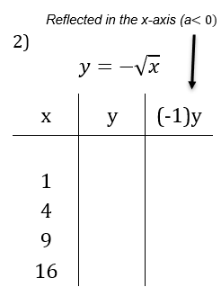

‘a’ = Starting Point, (h,k) = Domain Range

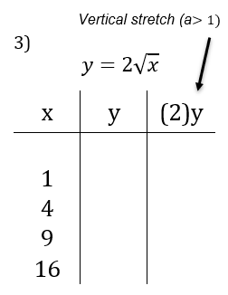

‘a’ = Starting Point, (h,k) = Domain Range

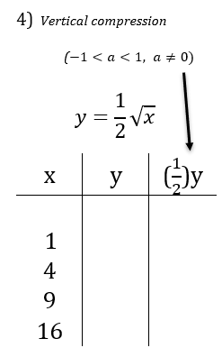

‘a’ = Starting Point, (h,k) = Domain Range



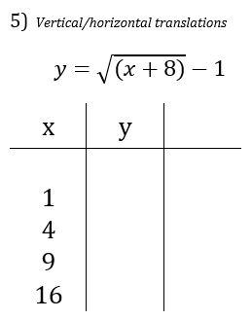

‘a’ = Starting Point, (h,k) = Domain Range

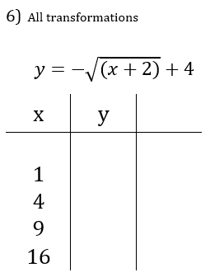

‘a’ = Starting Point, (h,k) = Domain Range

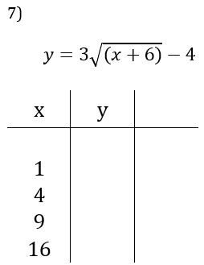

‘a’ = Starting Point, (h,k) = Domain Range

HW: 5.3 WS

5.3 WS - Graphing Radicals

Graph each function and determine the domain and range.



$$y=\sqrt{x+3}$$

Domain:

Range:

h , k

a = ( , )





Domain:

Range:

$$y=\sqrt{x}-5$$

h , k

a = ( , )

1. 

Domain:

Range:

$$y=2\sqrt{x+4}$$

h , k

a = ( , )

1. 

Domain:

Range:

$$y=\frac{-1}{2}\sqrt{x+7}+2$$

h , k

a = ( , )

$$y=3\sqrt{x+8}-4$$

1. 

Domain:

Range:

h , k

a = ( , )

6)



$$y=\frac{-1}{2}\sqrt{x+6}-3$$

Domain:

Range:

h , k

a = ( , )

 7)

$$y=-2\sqrt{x-1}+6$$

Domain:

Range:

h , k

a = ( , )

 8)

$a) y=\sqrt{x}$

$$b) y=-\sqrt{x}$$

$$c) y=x^{2}$$

**Graph all 3 on the same graph**

What do you notice about the graphs of

a&b compared to the graph of c?

What do you notice about their table of

values

5.4-Solving Radicals by Graphing

**Review:**

Graphing each of the following (Review):

$$Linear y=mx+b Quadratic y=a{(x-p)}^{2}+q Radical y=a\sqrt{x-h}+k$$

a. $y=5$ b. $y=\frac{1}{2}x-3$



c. $y=\frac{1}{4}{(x-2)}^{2}-3$ d. $y=2\sqrt{x+6}-4$

Solving graphically means to find the _____ value(s) at which two functions cross or intersect.

Let's practice solving radical equations graphically. To do so we must…

1. Rearrange the equation to isolate the radical function (if necessary)
2. Graph the left side as y1
3. Graph the right side as y2
4. State the x-value(s) at which the two equations cross – the point at which the equations are equal.

a. $\sqrt{x+4}=3$ b. $\sqrt{x-1}=3-x$



c. $x-1=5-3\sqrt{x-2}$ d. $3\sqrt{x}={\left(x-2\right)}^{2}+2$

HW: 5.4 WS



5) 6)





7) 8)



5.5-Solving Radicals using Algebra

**Review**: $\sqrt{2}*\sqrt{2}= \sqrt{x}*\sqrt{x}=$ $\sqrt{x-3}*\sqrt{x-3}=$

Like solving by graphing, solving through algebra means to find the ________________ where the two functions cross or intersect.

To solve *algebraically* we must

1. Identify the restriction(s) on the variable under the root. This is the same as determining the domain in which the function exists.
2. Isolate the radical on one side of the equation.
3. Square both sides of the equation to remove the radical.
4. Solve for x.
5. Make sure the x-value is within the domain of the function. Check your solution(s) back into any equation with a radical to make sure there are no extraneous sol'ns.

Solve using algebra:

$5+\sqrt{2x-1}=12$

Solve using algebra:

$-8+\sqrt{\frac{3x}{5}}=-2$

$x+\sqrt{x-1}=3$

$$2x=-4+2\sqrt{2x+7}$$

$$7+\sqrt{3x}=\sqrt{5x+4}+5$$

HW: 5.5 WS

5.5 WS - Solving Radical Equations – Algebraically

Solving the following equations algebraically, state restrictions, check your solutions and show your work.

$1. \sqrt{2x+31}=x-2$ $2. \frac{1}{3}\sqrt{-4-m}=\frac{1}{3}$

$3. \sqrt{6x+3}=x+2$ $4. b=\sqrt{-10+7b}$

$5. 2\sqrt{-12+8x}=2x$ $6. \sqrt{4n-7}=5$

$7. x-4=\sqrt{2x}$ $8. 2\left(x+1\right)=2\sqrt{3x+31}$

$9. \sqrt{3x+4}=1+\sqrt{2x+1}$

Solutions

1. x=9

2. m=-5

3. x=1

4. x=2,5

5. x=2,6

6. x=8

7. x=8

8. x=6

9. x=0,4